Maths

Number: Place Value – Roman numerals to 100. Round to the nearest 10. Round to the nearest 100, Count in 1000, partitioning. Number line to 10,000. 1000 more and less. Comparing and ordering numbers. Rounding to the nearest 1000. Negative numbers.

Number: Addition and Subtraction – Add and subtract up to 1000. Add two 4 digit numbers with and without exchange. Subtract two 4 digit numbers with and without exchange. Efficient subtractions, Estimating answers, checking strategies.

English
Reading - Here We Are by Oliver Jeffers
Viking Boy by Tony Bradman
We will be using our Traders and Raiders topic and our class text ‘Viking Boy’ to develop our English Skills this half term. We will also be developing our story writing skills by analysing the stories of our favourite authors.

We will speculate, hypothesise and imagining what it might have been like to be a Saxon invader landing on the beaches of Norfolk and how onlookers might have felt

We will write a report on the arrival of the Saxons on Brancaster beach

We will use a range of source materials to find out about key figures in Anglo-Saxon Britain including the monk Bede and Arthur, a great leader who fought against the Angles and Saxons.

Developing pleasure and motivation to read.
Comprehension skills focusing on Y4 key skills/content domains in whole class reading, group reading and one to one reading sessions
Speaking and Listening – Take part in presentations or present different views on different questions or issues
Writing Composition - Writing for different purposes, developing stamina, editing and checking work throughout.
Spelling and Grammar: No Nonsense Spelling
linked to the National Curriculum requirements for Year 4.
Handwriting: Children join and enhance the fluency and neatness of their writing. Emphasis on neat presentation and pride in all written work.
Computing
Online Safety: Contact/Respect
- Use technology safely, respectfully and responsibly
- Recognise acceptable/unacceptable behaviour
- Identify a range of ways to report concerns about content and contact

Use technology safely, respectfully and responsibly
Recognise acceptable/unacceptable behaviour
Identify a range of ways to report concerns about content and contact

Religious Education
(According to Warwickshire and Coventry agreed syllabus for RE 2017)
Engaging pupils in enquiry into significant human questions which religion and worldviews address, so that they can develop the understanding and skills needed to appreciate and appraise varied responses to these questions, as well as develop responses of their own.

Exploring what a festival is and why they are important to various Religious traditions. Thinking particularly about Harvest and festivals where people give thanks for food and what the earth has provided.

Science
Broaden scientific understanding of the world through exploration, observation, research and testing in the topic area of evolution and inheritance
Through working scientifically, children will use and develop their practical scientific methods, processes and skills:
Planning different types of scientific enquiries; taking measurements, using a range of scientific equipment

Exploring electricity.

Construct a simple series electric circuit, Identifying and naming its basic parts
Identify whether a lamp will light in a simple series circuit based on whether or not the lamp is part of a complete loop with the battery.
Recognise that a switch opens and closes a circuit.
Recognise some common conductors and insulators.

Geography
Extend knowledge of the UK, Europe and the world; location and place knowledge; and significant human and physical features
Locate the world’s continents and countries using maps and atlases, describe and understand key aspects of physical geography Research Saxon shore forts and create a sketch map
Find out where Saxon invaders settled in Britain, searching for towns that have names derived from Saxon words.

Traders and Raiders
Curriculum Plan – Autumn 1 2020
Year 4 Mr Moss

British Values and SMSC
Developing an understanding of fundamental British values
Spiritual: developing our understanding of ourselves and engaging our heart as well as our mind in our learning and interactions with others. Developing self-awareness through mindfulness begun in year 3.
Moral and social: Increasing understanding of how our actions affect others and our responsibility towards others in school
Cultural: Explore how those who have come to Britain have shaped and enriched culture
Democracy: Listen to other people’s opinions and ideas, learning to respond and respectfully disagree, debating open ended questions

Super Start: Colour Monster – create a rainbow of hope

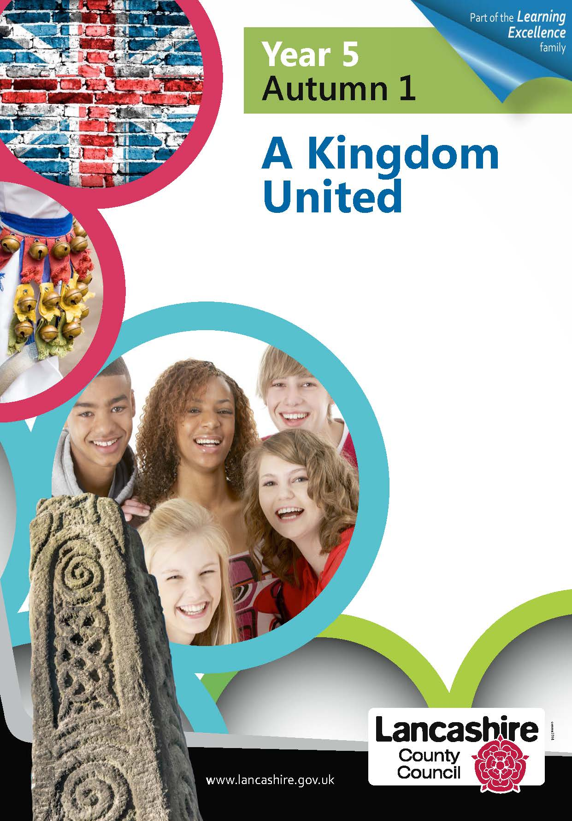
Physical Education

Developing movement skills, competence, agility and coordination individually and with others across a range of physical activity
Games – Invasion Games developing ball skills and team work approach to ball games

Art
Developing creativity using a variety of materials within the following contexts:

Learning about scale and proportion, drawing from close observation to capture fine details - drawing

Look at Anglo Saxon pottery and create own pot out of clay.

History
Develop chronological knowledge noting connections, contrasts and trends over time. Use historical terms, ask valid questions and construct informed responses.
Children will study an aspect or theme in British History that extends their chronological understanding up to 1066, Place events, people and changes within a chronological framework.
- Make connections, draw contrasts and identify trends in different periods of history.
- Give reasons for and write explanations of past events using evidence to support.
- Use a range of sources to select, organise and present relevant information.
- Acknowledge different points of view and understand how these are important when looking at interpretations of history.
Historical Figure, Bede and Arthur

.?:

PSHE
New Beginnings we will be using the texts Colour monster and We are Here to explore our thoughts and feelings about returning to school after lockdown. We will also be learning about:
Our rights and responsibilities in the school context
Some of the things that help us in school to learn and play well together
The need for rules in society and why we have the rules we do in school
That if I don’t agree with something in school I know how to go about trying to change things
How to work well in a group
How it feels to do/start something new and why
It also links clearly with our SMSC development.

Spanish
Build on work in year 3 to develop the ability to have a simple conversation with increasing confidence and breadth of vocabulary

