DO NOT HAND THIS SHEET BACK IN, YOU WILL NEED IT EACH WEEK!
Year 5 English homework
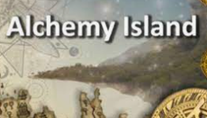

Alchemy Island
Choose one activity below for each piece of English homework.
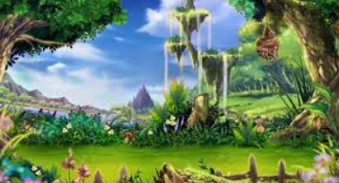  Write a fantasy story- remember many fantasy novels begin with a portal or doorway to another world. | Build a 3D fantasy island. Use a range of natural materials to build your very own island.  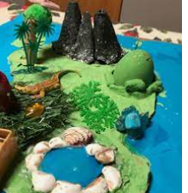  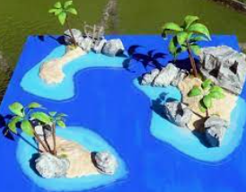 | 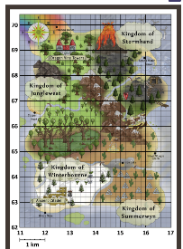  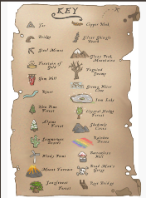  Design a map of your new island, a key for the map and a riddle to explain where the journey begins.
Research a precious metal or gemstone- what interesting facts can you find. Draw and label a diagram.  Find out atomic numbers and symbols for metals, such as lead, copper, silver, zinc, irons and platinum. A periodic table will help you! | Joker Box Task  Create your own piece of English homework this week! | 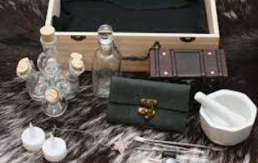  Design a costume and travel kits for an alchemist- remember all the useful things they would pack.

