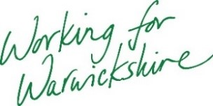
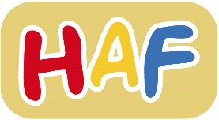
22nd March 2022

Dear Headteacher,

Holiday Activities and Food (HAF) Programme Easter 2022
We are delighted to share with you an update on the HAF programme.
The HAF programme will be delivered in Warwickshire over the upcoming Easter holiday period. We have over 70 providers across the county delivering free face to face activities which will include a healthy meal. Each eligible child can access up to four days of activities over the two weeks of the Easter holidays; from Monday 11th April to Friday 22nd April.
HAF is for those aged 4 to 16 who are in full-time education and receive benefits-related free school meals. All children receive universal free school meals in reception, years 1 and 2. This isn't entitlement to HAF, as it isn't benefits tested. Eligible families were sent a unique HAF code last week via text and e-mail from WCC (Warwickshire County Council). They can use this code to book activities direct with providers.
We are also making HAF places available to vulnerable families in Warwickshire. Families who fit the following criteria should contact the HAF team and ask for a code:
- Allocated social worker
- Allocated family support worker
- Open early help plan
- Young carer
There is a wide range of activities available including multi-sports, arts and crafts, drama and equestrian. Details on all the Easter activities can be found by clicking the Easter HAF activities link on the Children and Families homepage.
We are working closely with providers to ensure that Warwickshire’s HAF provision is as inclusive as possible. If a child needs additional support to access an activity due to additional needs or transport costs, parent/carers should discuss this directly with providers who are able to access additional funding.
Action for schools
- Make eligible children and families aware of the programme.
- Advice families with an open early help plan about the scheme and how to apply.
- Encourage families who are not receiving free school meals to check eligibility and apply here.
- Encourage eligible families to see what activities are on in their local area on the Children and Families homepage.
For any queries please contact hafprogramme@warwickshire.gov.uk or ring the Family Information Service Helpline 01926 742274
Please note: In addition to the HAF programme The Local Welfare Scheme is offering support for families on benefits tested free school meals in the form of a supermarket voucher from voucher supplier Hugg. Vouchers will be issued automatically direct to families.

Kind regards,
Warwickshire HAF Team

