Stratford Upon Avon Primary School - Long Term Plan – Year Four 2020 -2021
Autumn 1  Traders and Raiders  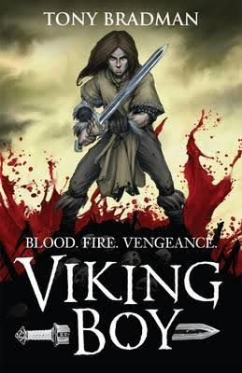 | Autumn  Victorians  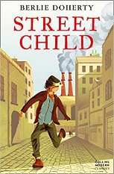 | Spring 1  Burps, bottoms and bile  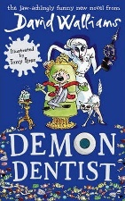 | Spring 2  Gods and mortals  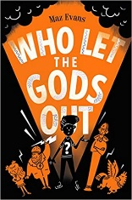 | Summer 1  Potions  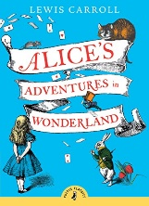 | Summer 2  Blue Abyss  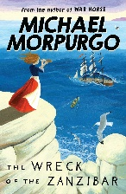
Super Starter:  Build a castle | Super Starter:  Come to school as a Victorian | Super Starter:  Plaque Investigation | Super Starter:  Design your own Greek God | Super Starter:  Making potions | Super Starter:  Under the sea party
Key Texts:  Viking Boy by Tony Bradman  Monster stories and legends | Key Texts:  Street Child  Vile Victorians  Great Expectations | Key Texts:  Demon Dentist by David Walliams | Key Texts:  Who let the God’s out  Maz Evans | Key Texts:  Alice in Wonderland  Macbeth by William Shakespeare | Key Texts:  The Wreck of Zanzibar by Michael Morpurgo  The Tempest by William Shakespeare
Geography:  Maps of Roman shore forts | Geography:  Local Geography, Maps | Geography:  Settlers  (not linked to topic) | Geography:  Sketch maps of Ancient Greece | Geography:  x | Geography:  Seas/Oceans/  environmental issues
History:  Traders and Raiders to 1066 | History:  Victorian Britain, Victorian Stratford | History:  x | History:  Ancient Greece timeline | History:  How potions have been used in the past | History:  19th Century sea expeditions
Art:  Bayeux Tapestry | Art:  William Morris | Art:  Creating a model of a mouth | Art:  Modroc Greek Gods  Painting Greek Pottery | Art:  Use a range of resources to create potions | Art:  Watercolours of the seas
Artist:  x | Artist:  William Morris | Artist:  Damian Hirst | Artist:  Kachrylion  Red-figure pottery | Artist:  Jim Kay | Artist:  J M Turner
D&T:  Sewing | D&T:  Tile printing | D&T:  Designing a toothpaste and box | D&T:  x | D&T:  Design a chocolate bar | D&T:  Submarines
Science:  x | Science:  The water cycle | Science:  Teeth  The digestive system | Science:  x | Science:  Changing states | Science:  Animals/sound
Sig person:  Alfred the Great | Sig person:  Charles Dickens | Sig person:  David Walliams | Sig person:  Homer | Sig person:  Marie Curie | Sig person:  David Livingstone
R.E:  Why do some people think life is a journey? | R.E:  Victorian churches  Oxford Movement decoration | R.E:  What does it mean to be a Hindu in Britain today?  Visit to Hindu Temple | R.E:  Why are festivals important to religion? | R.E:  Why do people pray? | R.E  What significant experiences link to life is a journey?
PSHE:  Treating others with respect.  Protective behaviours.  Catch it, bin it, kill it!  Building relationships.  We are here  Mindfulness colouring | PSHE:  Think Positive  Protective behaviours  Belonging to a community (link to Street Child)  Anti-bullying week  Mindfulness colouring | PSHE:  One world  Healthy lifestyles  Catch it, bin it, kill it!  Mindfulness Colouring | PSHE:  Respecting Rights  Mindfulness Colouring | PSHE:  Safety First  (link to Alice in Wonderland)  Mindfulness Colouring | PSHE:  Growing up  RSE  Transition; moving on, looking back (link to class book)  Mindfulness Colouring
PE  Ball control | PE  Dance | PE  Problem Solving | PE  Invasion games | PE  Gymnastics | PE  Rounders
Computing  Online Safety | Computing  Data handling | Computing  Programming | Computing  Data handling | Computing  Networks and trustworthy sites | Computing  Multimedia presentations
Music  Rhythmic patterns | Music  Victorian Composers | Music  Using your body to make music | Music  Exploring melodies and scales | Music  Spell music | Music  Ocean commotion
SMSC:  Colour Monster  Exploring our feelings | SMSC:  What is it like to live in the clouds? | SMSC:  What is your food footprint? | SMSC:  Could you leave your home and community behind? | SMSC:  What is a health footprint? | SMSC:  Is water a basic human right?
Fabulous finish:  Viking feast | Fabulous finish:  Victorian afternoon tea | Fabulous finish:  Trip to Science Museum | Fabulous finish:  Year 3/4 production | Fabulous finish:  Science/potions workshop. | Fabulous finish:  Aquarium visit – local garden centre

