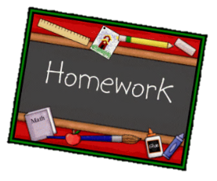
Year 1 English homework Autumn 2
Choose one activity below for each piece of English homework.
Complete work in your homework book. Remember to put it into the homework tray by the due date for marking (always on a Wednesday):
16th January (interview homework only), 29th January, 12th February
Creative tasks and joker box tasks can be completed on additional paper if needed. Please ask if you need anything else.
At the bottom of your homework, ask a grownup to sign and make a comment on your piece of work.

Write a poem about a family member. | Write a paragraph about how people celebrate the Chinese New Year. | If you could sail anywhere in the world, where would it be? The answer does not have to be a real place.
CREATIVE TASK 1  Create a new front cover for our book ‘Ocean meets Sky’. | JOKER BOX  Make up your own piece of English homework. Try to link it to our work in the classroom. | CREATIVE TASK 2  Make a model of an under the sea creature.

