DO NOT HAND THIS SHEET BACK IN, YOU WILL NEED IT EACH WEEK!
Year 5 English Homework
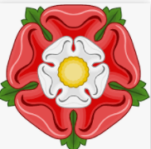

The Tudors
Choose one activity below for each piece of English homework.
Design and make a Shakespeare photo booth prop,  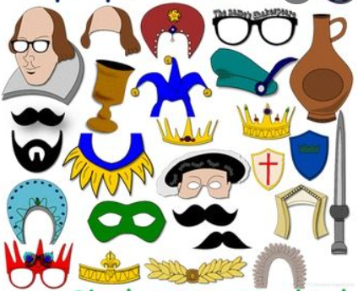 | Create a Fact file about Henry VIII.  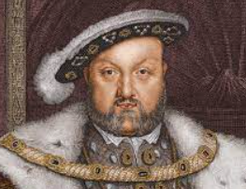  Remember to include facts about his marriages. | Create a Tudors mnemonic.  T_______  U_______  D_______  O_______  R_______  S_______
Make a mini Tudor Building.  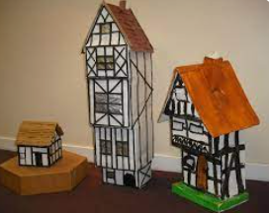 | Joker Box Task  Create your own piece of English homework this week! | Research some famous Tudor buildings and create a PowerPoint.  