Maths
Money
Name coins and understand their value.
To represent the same value using different coins.
Understand how to use money in a real life context.
To exchange money for items.
To solve addition and subtraction word problems using money.
To find change from given amounts.
Multiplication and Division
To find double and half of an amount.
To add equal groups.
To share a total equally between a set number of groups.
To share a total equally and find the number of groups.
To explore arrays.
To build on previous understanding of halves and quarters of quantities.
Capacity and Volume
Direct comparison of the capacity of two containers.
Indirect comparison of the capacity of two containers using non-standard units.
Comparison of volume, visually (in identical containers) and using non-standard units.
Applying understanding of halves and quarters to capacity.
Introducing litres.
Exploring difference by comparing lengths and volumes.
Applying measuring skills in real-life context.

English
Reading - Key texts: Katie in London by James Mayhew, The Queen by Steve Antony, Great Fire of London information texts.
Developing pleasure and motivation to read. Comprehension skills focusing on Y1 key skills/content domains both during whole class reading and guided group reading.
Speaking and Listening – Participating in discussions, drama and role play activities based on Katie in London. Working in groups to re-tell a text.
Writing Composition - Writing for different purposes and audiences.
Nonfiction: Plan and write an information text on a London landmark Compare London to Stratford-upon-Avon. Write a recount on the Great Fire of London.
Fiction: Write a letter to and from the Queen.
Poetry: Writing a poem based on London
Spelling: Weekly and daily phonic focus as well as concentrating on the correct spelling of tricky words.
Grammar: Linked to the National Curriculum requirements for Year 1. Main focus: use of paragraphs to organise ideas around a theme, noun phrases expanded by modifying verbs.
Handwriting: A focus on presentation and correct letter formation.

Art
Developing creativity using a variety of materials within the following contexts:
Creating abstract art based on London landmarks,
Creating a cityscape using a range of materials.
Painting half-timber houses.
Science

Investigate what buildings were made out of in the 1600s and how this helped spread the Great Fire of London.
Explore changing materials and properties by baking bread using a similar recipe to the ones used in the 1600s.
Observe and compare seasonal changes.

Geography

Researching London landmarks and mapping them across the River Thames.
Using world maps, atlases and globes to identify the United Kingdom and its countries and capitals.
Comparing the layout of London during the 1600s to its layout today.

Physical Education
Developing movement skills, competence, agility and coordination individually and with others across a range of physical activity.

Athletics
Travelling in different ways to involve whole body and mobilise joints when warming-up.
Engage in pulse-raising running and avoiding games to develop spatial awareness and control.

Develop skills in:
- Changing speed
- Control in picking up/putting down equipment
- Underarm throwing
- Simple take-offs and landings
Working co-operatively.

Curriculum Plan – London 2019
Year 1 Summer 2 Miss White

Super Starter: London Landmarks artwork
Fantastic Finish: Afternoon tea party


Design and Technology
Designing and making functional, purposeful appealing products and evaluating these.
Designing and making houses similar to those in 1666.

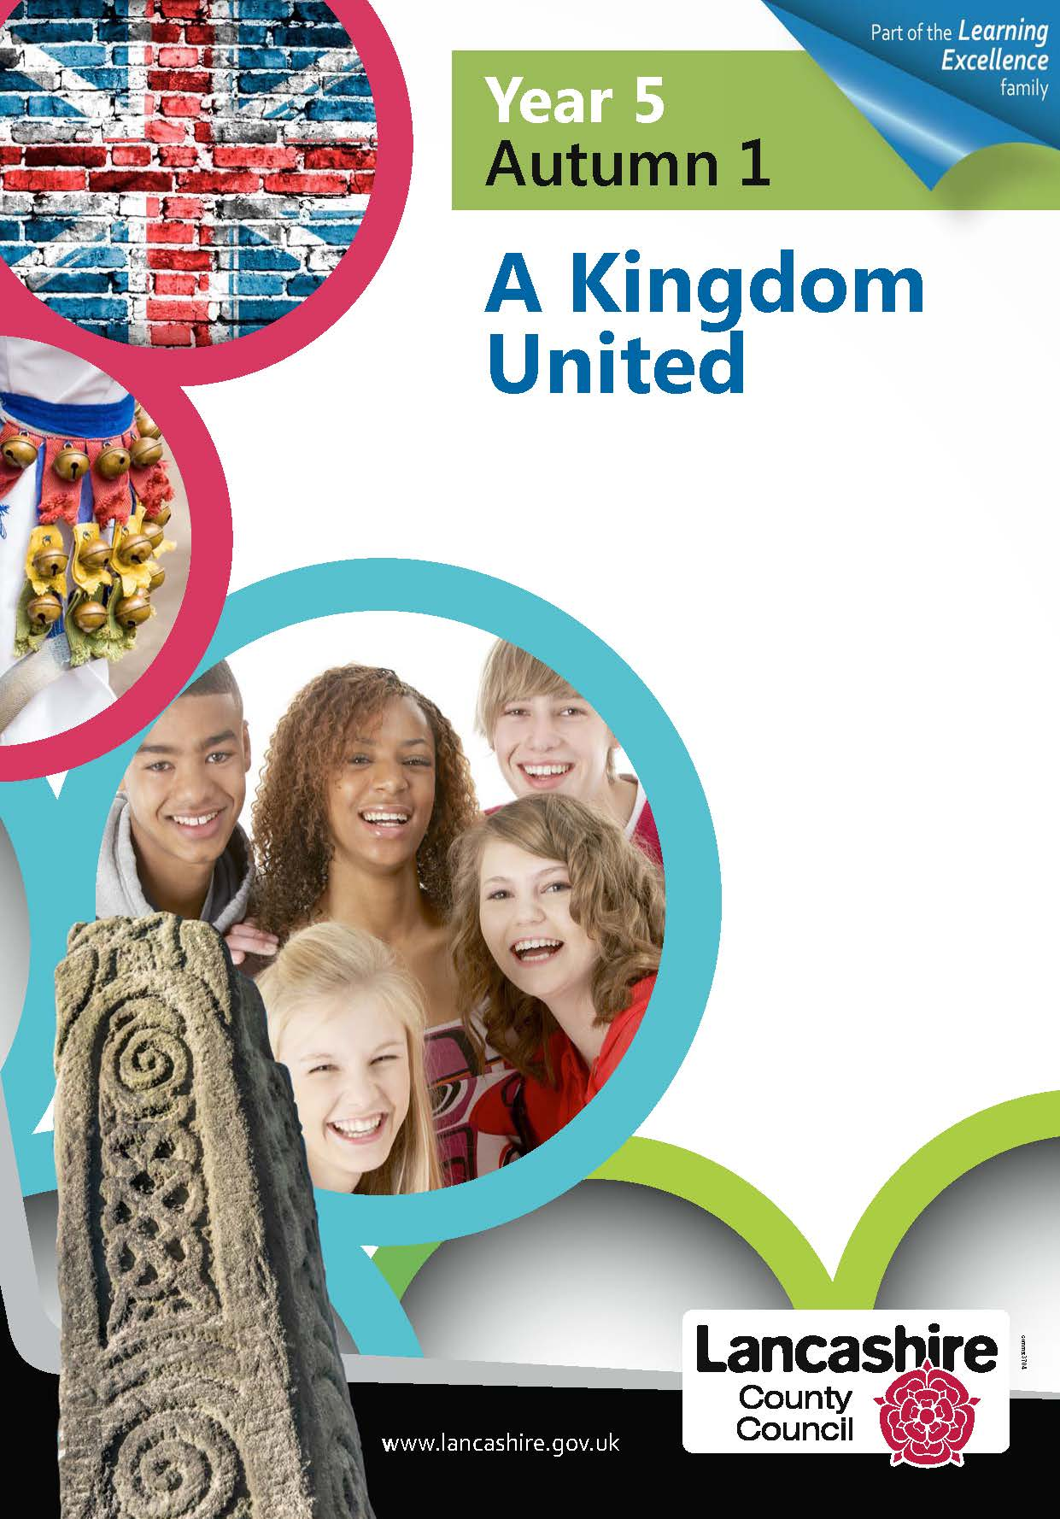
Religious Education
(According to Warwickshire and Coventry agreed syllabus for RE 2017)
Engaging pupils in enquiry into significant human questions which religion and worldviews address, so that they can develop the understanding and skills needed to appreciate and appraise varied responses to these questions, as well as develop responses of their own.
What does it mean to belong to a faith community?

In RE we will explore how different religions show that they belong to a community as well as exploring different religious ceremonies.

PSHE
Preparing for change and celebrating differences.

It also links clearly with our SMSC development.

British Values and SMSC
Developing an understanding of fundamental British values
Throughout the curriculum we will seek to promote the values of democracy, the rule of law, individual liberty and mutual respect and tolerance of those with different faiths and beliefs. Focus on the rule of law and balancing rights with responsibilities.

History
Exploring the Great Fire of London and how it was caused.
Researching how London has changed over history.
Exploring the lives of people who lived in London during the 1600s and how it is different to people who live in London today.

Computing

Practising using our log ins and passwords, using Microsoft Word to type and create an information page. Using internet search engines.

Spanish
Learning familiar songs and rhymes in Spanish.

Music
Learning familiar songs about London e.g. London’s burning and singing in a round.

