Year 1
Writing Teacher Assessment Framework
Working At the Expected Standard
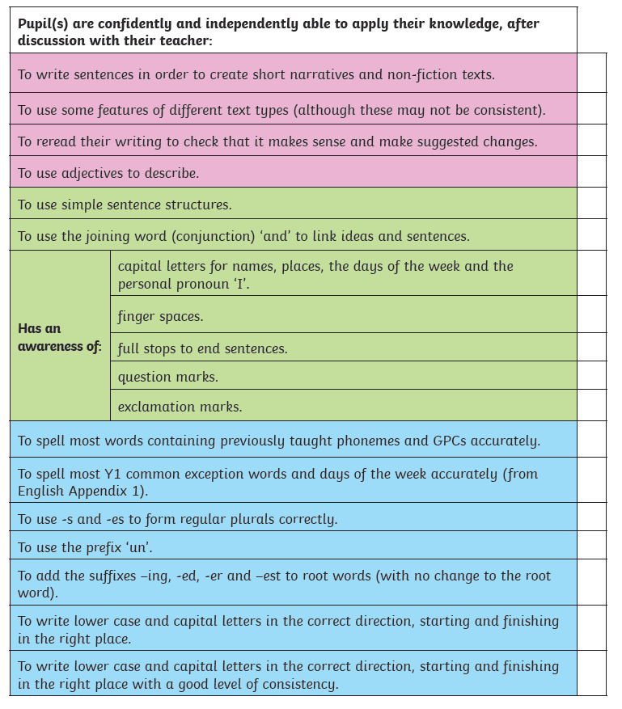
To note;
- Each TAF has been created to link explicitly to the expectations set out in the 2014 English National Curriculum for Writing.
- Statements have been set out in colour-coded boxes: pink for composition; green for grammar and punctuation and blue for transcription.
- All of the statements are progressive within and across the year groups, and work on the expectation that the majority of pupils will be working on their own year group’s aims. Consequently, the criteria for Working Towards for one year group is not the same as the criteria for Working at Greater Depth in the previous year group.

