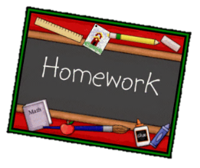
Year 1 English homework Autumn 1
Choose one activity below for each piece of English homework.
Complete work in your homework book. Remember to put it into the homework tray by the due date for marking (always on a Wednesday):
19th Sept, 3rd Oct, 17th Oct
Creative tasks and joker box tasks can be completed on additional paper if needed. Please ask if you need anything else.
At the bottom of your homework, ask a grownup to sign and make a comment on your piece of work.

Create a different front cover for your reading book. | Make up your own fairy tale character and draw a picture of them. Include two sentences describing your character. | Draw a character from your book. Write a description about them.
Which fairy tale is your favourite? Write a paragraph giving three reasons why it is your favourite. | Design the front cover of your favourite fairy tale. Remember to include the title and author. | Write five questions you would ask Goldilocks.  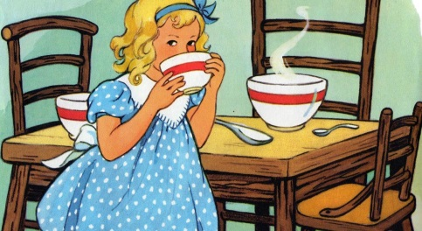
CREATIVE TASK 1  Make some gingerbread men. Take lots of photos and stick them in your homework book. | JOKER BOX  Make up your own piece of English homework. Try to link it to our work in the classroom. | CREATIVE TASK 2  Create a fairy tale setting in a shoebox. Will it be an enchanted wood? Or a castle?

