DO NOT HAND THIS SHEET BACK IN, YOU WILL NEED IT EACH WEEK!
Year 5 English Homework
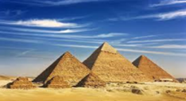

Pharaohs
Choose one activity below for each piece of English homework.
Design your own 2-D or 3-D Egyptian-style jewellery  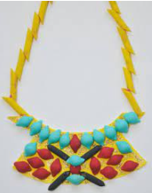  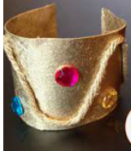  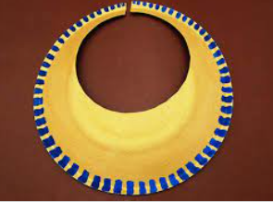 | 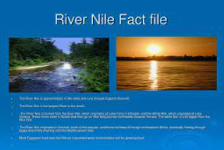  Create a fact file about the river Nile and compare it to other famous world rivers. Include photographs and show a range of amazing animals that live in and by the river. | Make a model pyramid.  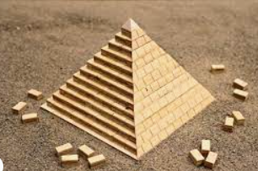  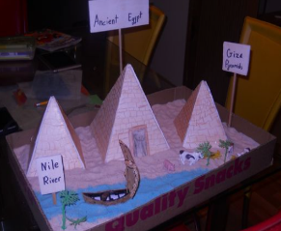  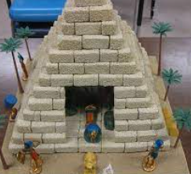
Use hieroglyphics to write a message to a friend or family member. Can they crack your Egyptian code?  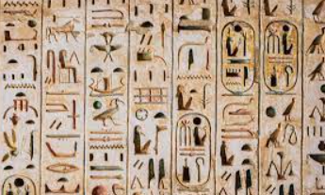 | Joker Box Task  Create your own piece of English homework this week! | Find out what ‘Ka’ WAS. Design a colourful symbol that might represent ‘Ka’ in Egyptian hieroglyphics.  