Stratford Upon Avon Primary School - Long Term Plan – Year Three 2020/21
Autumn 1  We Go Again! 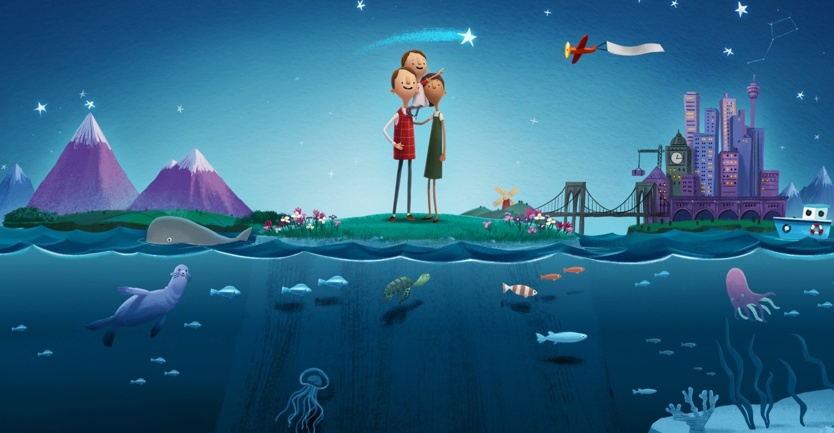 | Autumn 2  Scrumdiddlyumptious! 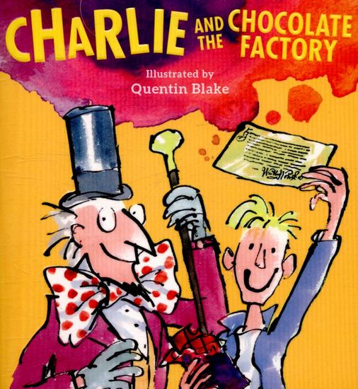 | Spring 1  Rampaging Romans! 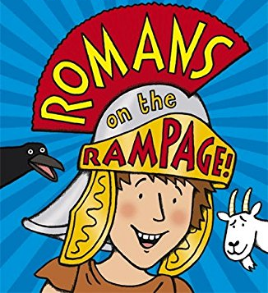 | Spring 2  The Floor is Lava! 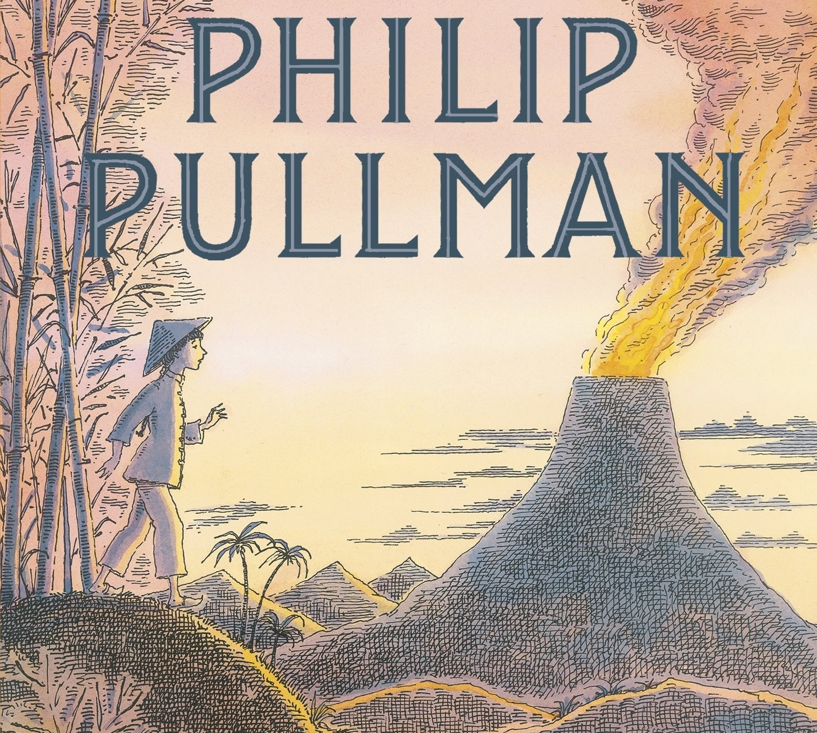 | Summer 1  Tribal Tales! 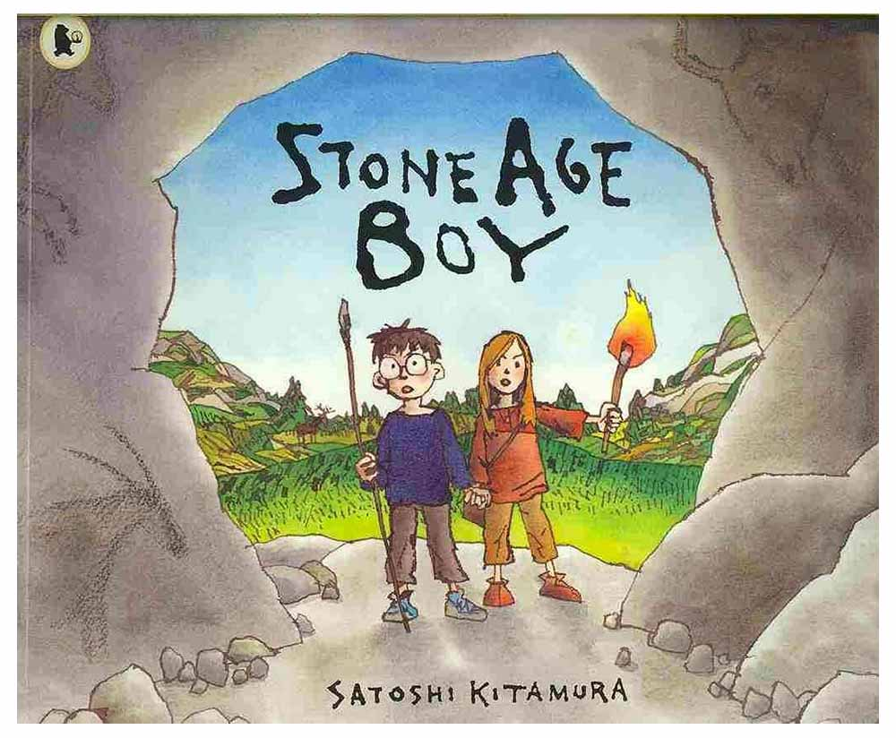 | Summer 1  Heroes and Villains! 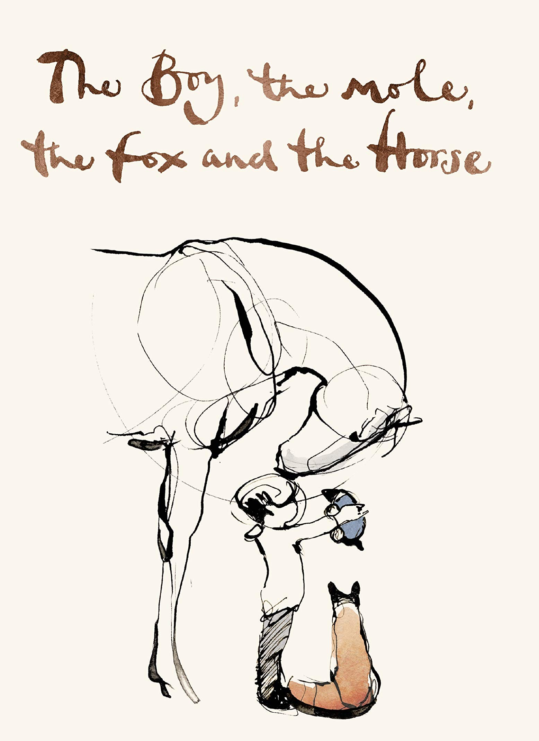
Super Starter:  Sharing our Happiness Boxes from the Summer Holidays | Super Starter:  TRIP: BOSTON TEA PARTY / HOORAYS / TESCO | Super Starter:  Making Roman shields | Super Starter:  Making exploding volcanoes! | Super Starter:  What’s happened to the classroom?! | Super Starter:  A mysterious box with a heavy lock is found. A sign on the box says ‘Do not open’. What should YOU do?
Key Texts:  Fantastic Mr Fox  by Roald Dahl  The Very Noisy Foxes by Amy Husband  Mr Wolf’s Pancakes  by Jan Fearnley | Key Texts:  Charlie and the Chocolate Factory  by Roald Dahl | Key Texts:  Romans on the Rampage  by Jeremy Strong | Key Texts:  The Firework Maker’s Daughter  by Philip Pullman  Escape from Pompeii  by Christina Balit | Key Texts:  Stone Age Boy  by Satoshi Kitamura  Stig of the Dump  by Clive King | Key Texts:  101 Dalmatians  by Dodie Smith  Various Comic books
Geography:  Using maps to locate features | Geography:  Food miles and fair trade | Geography:  Comparing Italy and the UK | Geography:  Volcanoes and Earthquakes | Geography:  Archaeological Digs  Aerial Photography | Geography:  Global mapping skills
History:  x | History:  The history of chocolate | History:  Ancient Rome | History:  Pompeii and Vesuvius Historical Eruptions | History:  Stone Age/Iron Age | History:  The art of alchemy
Art:  Predator sketches  Animal Prints | Art:  Drawing labels for products | Art:  Sculpture of people from Pompeii | Art:  Sculpture of people from Pompeii | Art:  Cave Paintings  Clay Art | Art:  Embossed patterns
Artist:  High Street Brands | Artist:  Cezanne & Arcimboldo | Artist:  Arellius (Roman Painter) | Artist:  Andy Warhol | Artist:  Cavemen | Artist:  Stan Lee
D&T:  Collage of birds  Peg Predators  Giant Class Predator | D&T:  Sculpture  Dessert cookery | D&T:  Design Roman shields  Roman bread  Roman mosaics | D&T:  Structures – building volcanoes | D&T:  Build own Stonehenge | D&T:  Superhero costumes  Hero bracelets
Science:  Food chains & Animals | Science:  Food & Nutrition | Science:  Plants/Light | Science:  Properties of rocks | Science:  x | Science:  Forces and Magnets
Sig person:  Roald Dahl | Sig person:  Joe Wicks | Sig person:  Boudicca | Sig person:  Pliny | Sig person:  Mesolithic/Neolithic People | Sig person:  Cruella de Vil
R.E:  What do different people believe about God? | R.E:  Why is Jesus inspiring for some people? | R.E:  Why do people pray? | R.E:  What does it mean to be a Christian in Britain today? | R.E  Linked to Stonehenge visit | R.E  What can we learn from religions about deciding what is right and wrong?
PSHE:  Key text: The Colour Monster by Anna Llenas  Behaviour  Happiness Boxes  Protective Behaviours  Building Relationships Catch it, Bin it, Kill it!  Mindfulness Colouring | PSHE:  Anti-bullying week  Protective Behaviours  Developing self-esteem and wellbeing  Catch it, Bin it, Kill it!  Mindfulness Colouring | PSHE:  Key text: Beegu by Alexis Deacon  Managing feelings  Catch it, Bin it, Kill it!  Mindfulness Colouring | PSHE:  Belonging to a community  Helping others  Catch it, Bin it, Kill it!  Mindfulness Colouring | PSHE:  SRE Curriculum  Catch it, Bin it, Kill it!  Mindfulness Colouring | PSHE:  Key text: The Boy, The Mole, The Fox and The Horse by Charlie Mackesy  Recognising and sharing feelings  Catch it, Bin it, Kill it!  Mindfulness Colouring
PE  Football  Netball | PE  Tag Rugby (Wasps visit)  Gymnastics (Val Sabin) | PE  Dance (Val Sabin)  Tennis | PE  Dance (Val Sabin)  Gymnastics (Val Sabin) | PE  Hockey  Rounders | PE  Athletics (Val Sabin)  Track and Field
Computing  Be Internet Sharp & Alert (Google Internet Legends) | Computing  Be Internet Secure, Kind & Brave (Google Internet Legends) | Computing  Digital Literacy  Touch Typing | Computing  Coding  Touch Typing | Computing  Debugging  Touch Typing | Computing  Programming  Touch Typing
Music  Charanga Year 3 – Let Your Spirit Fly  Musical Appreciation | Music  Charanga Year 3 -Glockenspiel Stage 1  Musical Appreciation | Music  Charanga Year 3 – Three Little Birds  Musical Appreciation | Music  Charanga Year 3 – The Dragon Song  Musical Appreciation | Music  Charanga Year 3 – Bringing Us Together  Musical Appreciation | Music  Charanga Year 3 – Reflect, Rewind and Replay  Musical Appreciation
SMSC:  Other species and our responsibility towards them | SMSC:  The Earth’s environment | SMSC:  How we, as humans, relate to one another | SMSC:  Our place on the planet as human beings | SMSC:  Belonging and community | SMSC:  Our responsibility as world citizens
Fabulous finish:  VISITOR:  REPTILE/BIRDS OF PREY EXPERIENCE | Fabulous finish:  Chocolate Making | Fabulous finish:  TRIP TO LUNT ROMAN FORT | Fabulous finish:  Year 3/4 Play! | Fabulous finish:  TRIP TO STONEHENGE | Fabulous finish:  Comic Book Sharing

