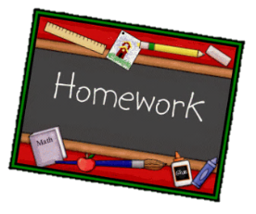
Year 1 English homework Summer 2
Choose one activity below for each piece of English homework.
Complete work in your homework book. Remember to put it into the homework tray by the due date for marking (always on a Wednesday):
18th June, 2nd July, 16th July
Creative tasks and joker box tasks can be completed on additional paper if needed. Please ask if you need anything else.

Research different capital cities. Which one is your favourite? How are they similar or different to London? | Write a short description about the events of the Great Fire of London. | Have you ever been to London? If you have write a paragraph explaining what you did and what you saw. If you haven’t write a paragraph explaining what famous sights you would like to see.
CREATIVE TASK 1  Create and label a map of your own fantasy city. What type of buildings will there be? What type of transport will people use? | JOKER BOX  Make up your own piece of English homework. Try to link it to our work in the classroom. | CREATIVE TASK 2  Bake your own bread. Remember to take a picture to show the rest of the class.

