Year 2 Writing Teacher Assessment Framework
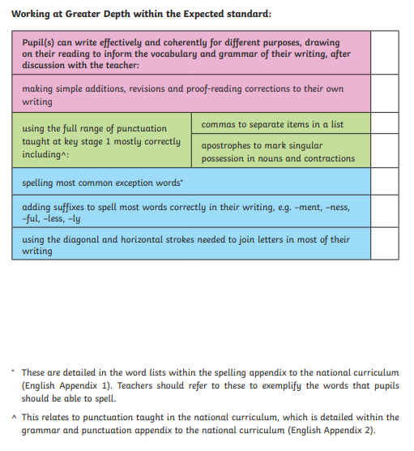
Working At Greater Depth within the Expected Standard

