Stratford Upon Avon Primary School - Long Term Plan – Year Five
Autumn 1  Stargazers | Autumn 2  Time Traveller | Spring 1  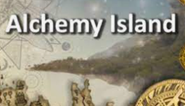  Alchemy Island | Spring 2  Tudors | Summer 1-Summer 2  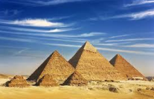  Pharaohs
Super Starter:  Trip: Space Centre | Super Starter:  MAD Museum | Super Starter:  The Dell | Super Starter:  Local Tudor Buildings | Super Starter:  Walk like an Egyptian
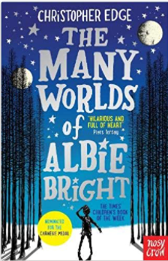  Key Texts:  What we will build by Olivia Jeffers  The many worlds of Abie Bright by Christopher Edge | 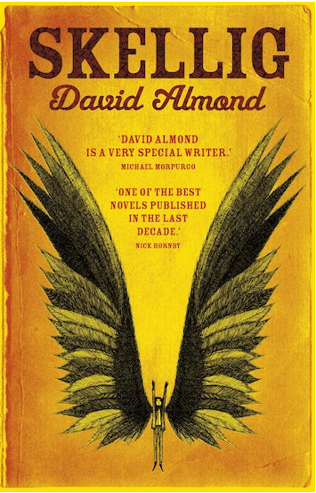  Key Texts:  Skellig by David Almond  The Time Machine by HG Wells  The Time Travelling Hamster | Key Texts:  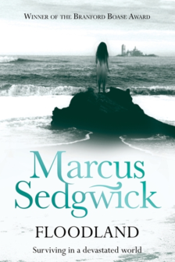  The comedy of errors, Shakespeare  Macbeth  Floodland  The girl of ink and Stars | 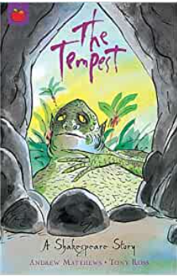  Key Texts:  Tempest  Shakespeare Week  Romeo and Juliet | Key Texts:  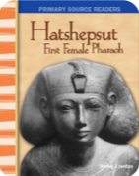  Hatshepsut | 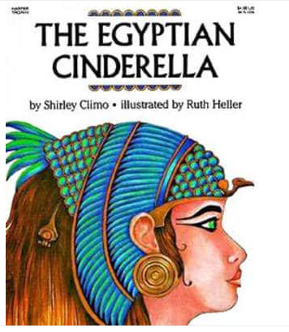  Key Texts:  Egyptian Cinderella Story by Shirley Climo
Maths: WR  Baseline Assessment Place Value Addition and Subtraction | Maths: WR  Statistics,Multiplication and division Perimeter and Area | Maths: WR  Multiplication and division Fractions | Maths: WR  Fractions Decimals and Percentages | Maths: WR Properties of Shapes Position and Direction | Maths: WR Converting Units Volume
Aut 2 - Geography:  Changes in the local community |  | Spr 1- Geography:  Local area map reading and ordinance mapping |  | Sum 1 - Geography:  Human and Physical features
Aut 1 - History:  History of planet discovery |  | Spr 2 - History:  The Tudors |  | Sum 2 - History:  Tutankhamun
Art:  Solar System Diorama  Chesley Bonestell | Art:  Sketches – what will I look like in the future?  Salvador Dali | Art:  Rise of the guardians  Christopher Appelhans | Art:  Tudor shields/portraits  Hans Holbein | Art:  Egyptian tapestry, designing headgear, hieroglyphics  Antony Gormley
D & T:  Moon Buggies | D & T:  Time Machines | D & T:  3D Alchemy Island | D & T:  Tudor Cookery/Houses | D & T:  Canopic jars
Science:  Earth and Space | Science:  Forces | Science:  Property of materials. | Science:  Animals, including humans | Science:  Living Things And There Habitats
Sig person:  Galileo Galilei | Sig person:  David Tennant | Sig person:  Marie Curie | Sig person:  Henry Viii | Sig person:  Howard Carter
RE- CWAS  Believing: Why do some people believe in God exists? |  | RE-CWAS  Expressing: If god is everywhere, why go to a place of worship? Visit local church |  | RE-CWAS  Living: What does it mean to be a Muslim in Britain? Food tasting/cultural clothing day
PSHE: Jigsaw  Being me in my world, Relax Kids | PSHE: Jigsaw  Celebrating Difference,  Relax Kids | PSHE: Jigsaw  Dreams and Goals, Relax Kids | PSHE: Jigsaw  Healthy me, Relax Kids | PSHE: Jigsaw  Relationships and changing me, Relax Kids
PE  Hockey | PE  Dance | PE  Gymnastics | PE  Tag Rugby | PE  Athletics |  | PE  Rounders
Computing  Internet safety | Computing  Data logging | Computing  Stop Dragons animation | Computing  Word Processing | Computing  Video presentations
Music- Charanga  Livin’ On A Prayer | Music-Charanga  Make You Feel My Love | Music-Charanga  Jazz | Music- Charanga  Lean on me | Music  Year 5/6 performance
Fabulous finish:  Stargazing Evening with Parents | Fabulous finish:  Topic Sharing event/adventure time stories. | Fabulous finish:  Orienteering at Heart England Forest | Fabulous finish:  Shakespeare Week- activities in town | Fabulous finish:  Egyptian Workshop

