Stratford Upon Avon Primary School - Long Term Plan – Year Two
Autumn 1  HERE WE ARE…  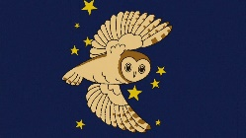  TOGETHER AGAIN  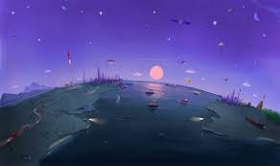 | Autumn 2  WHAT IS DARK? | Spring 1  THE STREET BENEATH OUR FEET  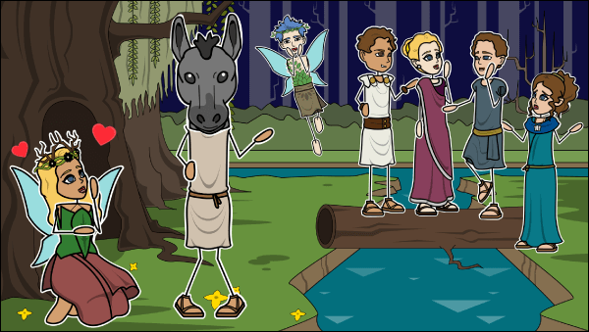 | Spring 2  LET THE WILD RUMPUS BEGIN!  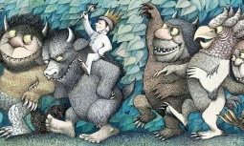 | Summer 1  ROOTS, SHOOTS, ANIMALS AND FRUITS  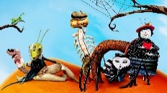 | Summer 2  WISHES FOR OUR WORLD  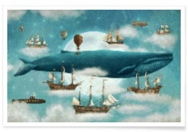
Super Starter:  Letter from outer space. | Super Starter:  Owl pellets investigation | Super Starter:  A Fairy visit to the classroom | Super Starter:  Shadow Dancing in the classroom | Super Starter:  Mini Beast Hunt | Super Starter:  Memory box in the classroom
Key Texts:  Here we are, by Oliver Jeffers  The Day the Crayons Quit, by Oliver Jeffers | Key Texts:  The Owl Who Was Afraid of the Dark, by Jill Tomlinson  The Dark, by Lemony Snicket | Key Texts:  A Midsummer Night’s Dream by William Shakespeare  The Sound Collector, by Roger McGough | Key Texts:  Where the Wild Things Are, by Maurice Sendak | Key Texts:  James and the Giant Peach, Roald Dahl. | Key Texts:  Ocean Meets Sky, by Eric Fan and Fan Terry  Dear Greenpeace, by Simon James  Michael Morpurgo, Wishes for our World
Geography:  Where do we live? Exploring planet Earth – continents, countries and capitals | Geography:  x | Geography:  Looking at our town  Reading and making maps | Geography:  Locating rainforests around the world;  Oceans | Geography:  Fieldwork, exploring natural habitats | Geography:  Mapping journeys
History:  Florence Nightingale – The Lady of the Lamp | History:  Bonfire Night – The Gunpowder Plot | History:  Looking at how the local area has changed over time. | History:  What caused the Titanic to sink? | History:  Charles Darwin and his voyage on HMS Beagle;  Peppered Moth | History:  How has the seaside changed throughout history?
Art:  Exploring primary and secondary colours;  Painting linked to the Day the Crayons Quit. | Art:  Firework paintings;  Starry Night;  Water colours and layering | Art:  Observational drawings;  Portraits of Shakespearean characters | Art:  Rainforest art;  Animal prints;  Oil pastels | Art:  Observational drawings and model making;  Making natural art outdoors | Art:  Illustrations;  3D models of Wild Things;  Collage
Artist:  Drew Daywalt | Artist:  Van Gogh | Artist:  Georgia O’Keefe | Artist:  Henri Rousseau | Artist:  Andy Goldsworthy | Artist:  Maurice Sendak
D&T:  Make a solar system orrery. | D&T:  Making shadow puppets | D&T:  Making character puppets;  Sewing and origami flowers | D&T:  Create a rainforest in a box;  Making boats;  Masks of Wild Things | D&T:  Origins of food, selecting natural materials  Making butterfly pizzas | D&T:  Making salt dough fossils;  Making and flying kites
Science:  Working scientifically:  Plants – do they need light or dark to grow? | Science:  Living things and their habitats;  Nocturnal animals  TRIP: FALCONERS VISIT | Science:  Plants (linked to A Midsummer Night’s Dream) | Science:  Everyday materials – making boats that float;  Waterproof materials | Science:  Living things including humans | Science:  Ocean habitats
Sig person:  Florence Nightingale | Sig person:  Guy Fawkes | Sig person:  William Shakespeare (playwright) | Sig person:  David Attenborough | Sig person:  Charles Darwin | Sig person:  Mary Seacole
R.E:  How should we care for others and the world and why does it matter? | R.E:  How and why do we celebrate special and sacred times? | R.E:  How and why do we celebrate special and sacred times?  TRIP: TRINITY CHURCH | RE:  How should we care for others and the world and why does it matter? | R.E:  Who is a Muslim and what do they believe? | R.E:  How should we care for others and the world and why does it matter?
PSHE:  Text:  The Colour Monster, by Anna Llenas  Behaviour  Happiness Boxes  Protective Behaviours  Catch it, Bin it, Kill it!  Board games  Building relationships;  Mindfulness colouring | PSHE:  Text:  Orion and the Dark, by Oliver Jeffers  Protective Behaviours  Building relationships, self-esteem and well-being  Catch it, Bin it, Kill it!  Anti-bullying week  Mindfulness colouring | PSHE:  Text:  After the Fall  by Fan Santat  Belonging to a community  Catch it, Bin it, Kill it!  Mindfulness Colouring | PSHE:  Text:  Beegu  By Alexis Deacon  Managing feelings  Helping others  Catch it, Bin it, Kill it!  Mindfulness Colouring | PSHE:  Text:  It’s Your World Now  by Barry Falls  Feeling positive  Catch it, Bin it, Kill it!  SRE Curriculum  Mindfulness Colouring | PSHE:  Text:  Somebody Swallowed Stanley, by Sarah Roberts  Recognise how other people are feeling;  Share their own feelings with others;  Recognise that we can affect how others feel;  Catch it, Bin it, Kill it  Mindfulness Colouring
SMSC:  Our responsibility as world citizens. | SMSC:  Belonging and community;  What are the wonders of the world? | SMSC:  Our place on the planet as human beings;  How do we help others in our community? | SMSC:  How we, as humans, relate to one another;  How can we accept, respect and celebrate differences in ourselves and others? | SMSC:  The Earth’s Environment;  How can we conserve and care for living things? | SMSC:  Other species and our responsibility towards them;  What can be done to make our seashores safe?
Fabulous finish:  Sending postcards to the local community – walking around Stratford delivering letters | Fabulous finish:  TRIP: FALCONER’S VISIT | Fabulous finish:  TRIP: Tudor World: William Shakespeare tour around Stratford upon Avon | Fabulous finish:  WILD THINGS RUMPUS PICNIC AND PARTY | Fabulous finish:  TRIP: ALL THINGS WILD – MINI BEAST TOUR  SPONSORED LITTER PICK? | Fabulous finish:  TRIP: ICE-CREAM MAKING - HOORAYS
 | National Poetry Day – Truth (October)  Anti-Bullying Week (November) |  | World Book Day - March

