**Upper Key Stage Two**

**Year 5**

**Reading Teacher Assessment Franewiwork**

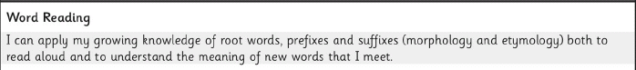

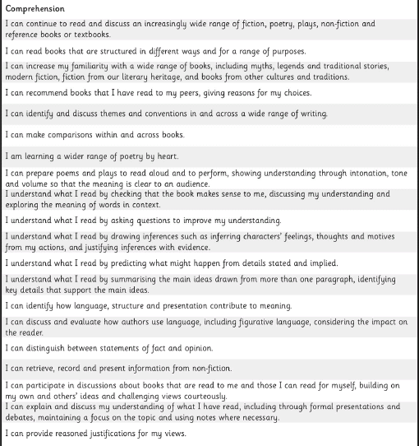

*To note;*

1. *The LKS2 and UKS2 checklists are based on the assessment guidance provided by the DfE in the curriculum, which does not differentiate between Working towards, Working At and Working at Greater Depth.*
2. *The statements have been separated into word reading and comprehension.*