Make up your own fairy tale character and draw a picture of them. Include two sentences describing them. | Little Red Hen – Write some speech bubbles for what the characters say. Can you write ‘Not I’ like the animals say when they won’t help the Little Red Hen. | Visit the library or use the internet to learn about crops that grow on farms.
Can you make some gingerbread men? Take lots of photos and stick them in your homework book. | Which fairy tale is your favourite? Write a paragraph giving three reasons why it is your favourite. | Make a windmill using cardboard boxes and take a picture to show Miss White.
CREATIVE TASK 1  Create a fairy tale setting in a shoebox. Will it be an enchanted wood? Or a castle? | JOKER BOX  Make up your own piece of English homework. Try to link it to our work in the classroom. | CREATIVE TASK 2  Draw the front cover of your favourite fairy tale.
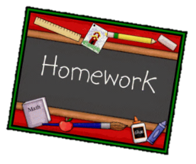
English Homework - Year 1 Autumn 1
Choose one activity below for each piece of English homework.
Complete homework in your homework book. Remember to hand it in on Wednesdays to be marked.
English homework due:
Wednesday 18th September, Wednesday 2nd October and Wednesday 16th October.
Creative tasks and joker box tasks can be completed on additional paper if needed. Please ask if you need anything else.

