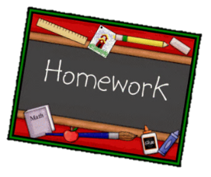
Year 1 English homework Summer 1
Choose one activity below for each piece of English homework.
Complete work in your homework book. Remember to put it into the homework tray by the due date for marking (always on a Wednesday):
8th May and the 22nd May
Creative tasks and joker box tasks can be completed on additional paper if needed. Please ask if you need anything else.

Write a poem or a song to encourage people to recycle. | Keep a record of how many objects you recycle each week at home. | Write a paragraph about what you do to help the Earth. It could be about recycling, litter picking, walking to school instead of driving, growing plants/vegetables etc.
CREATIVE TASK 1  Create your own ecobrick. Use a plastic bottle and pack it with plastics. Make sure you press the plastic in to make it dense. See https://www.ecobricks.org/how/  for more information | JOKER BOX  Make up your own piece of English homework. Try to link it to our work in the classroom. | CREATIVE TASK 2  Create something new out of something old. It could be adding detail to an old top or making a bag out of a piece of clothing you no longer wear.

