Stratford Upon Avon Primary School - Long Term Plan – Reception
Autumn 1  The Wonder of You | Autumn 2  To Infinity and Beyond! | Spring 1  Giants, Wolves and Super Veg! | Spring 2  Paws, claws and things that roar! | Summer 1  The Circle of Life  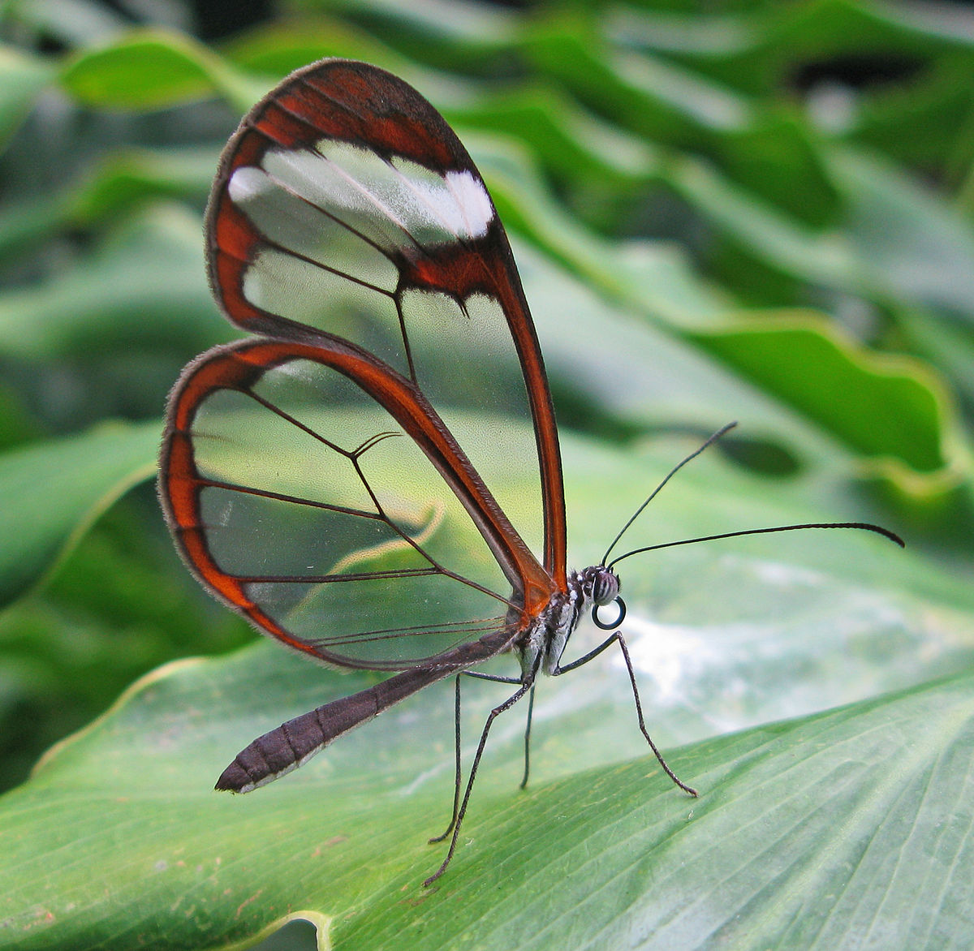 | Summer 2  What lies beneath…
Super Starter:  Adri the fish and the seascape | Super Starter:  A postcard from space/moon rocks | Super Starter:  Crime scene for the Three Little Pigs  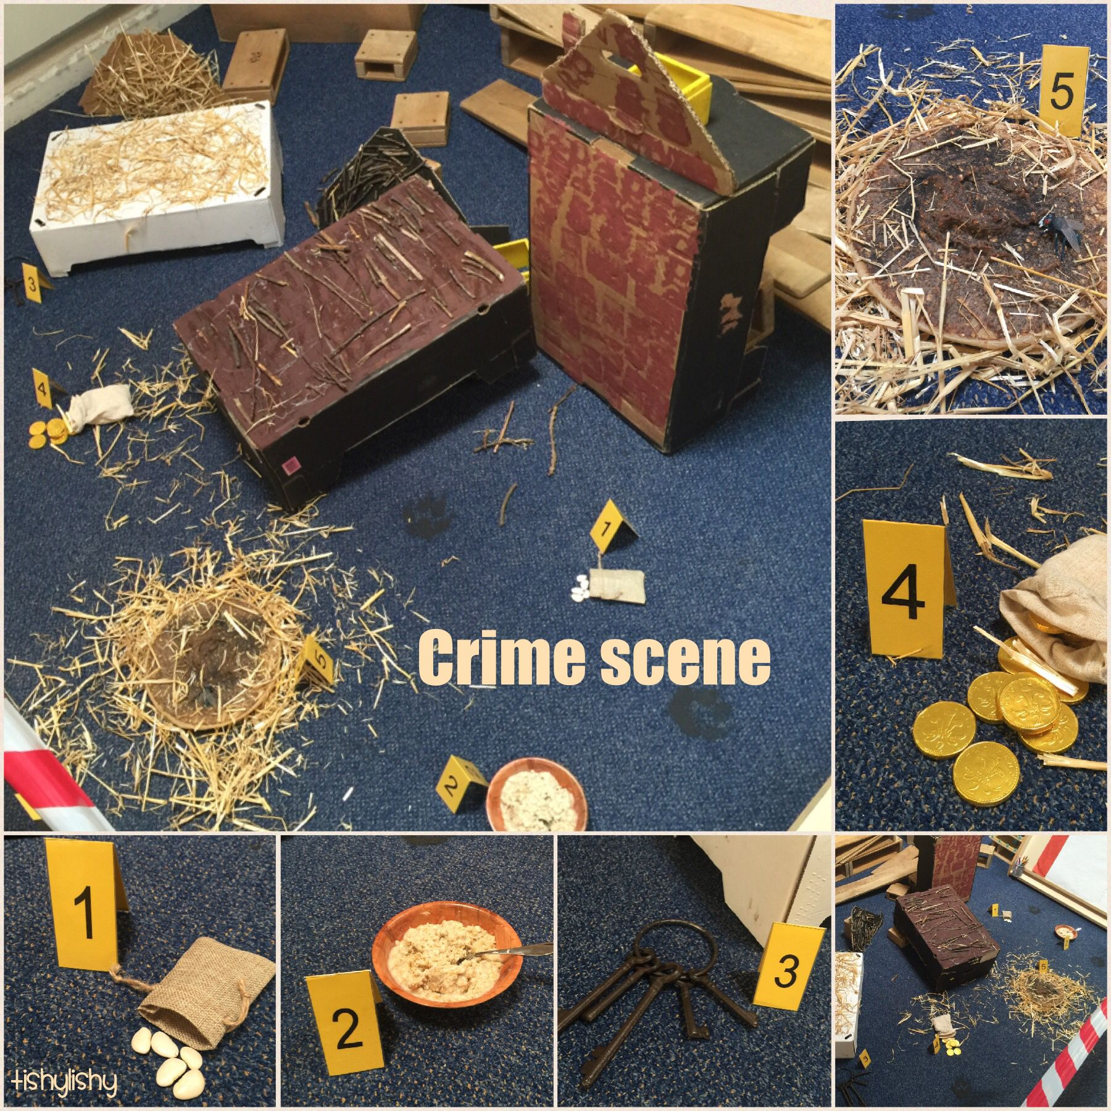 | Super Starter:  Deep Dark Wood role play outdoors - hunt for clues.  *Order caterpillars for next term! | Super Starter:  Butterfly Farm visit | Super Starter:  Washing line with pirate pants and other clues.
Key Texts:  Here we are  The Colour Monster  Only One You, You be You  Rainbow Fish  Ten fat sausages (Maths) | Key Texts:  Aliens love underpants  Aliens love underpants save the world  Whatever Next  Sausage dog Sid (Maths) | Key Texts:  Jack and the beanstalk  The three little pigs  The enormous turnip  Rosie’s walk (Maths)  The little red hen (Maths) | Key Texts:  Tell me a dragon  The Gruffalo  The smartest giant in town  Actual Size (Maths) | Key Texts:  The Very Hungry Caterpillar  Owl Babies  Great Pet Sale  What the ladybird heard (Maths) | Key Texts:  The night pirates  Pirates love underpants  One is a snail, ten is a crab (Maths)
English  Phase 1 and 2  Rhyming  All about me  Name writing | English  Phase 2  Labels  Name writing  Capitals and lower case letters | English  Phase 3  Story maps  Sequencing  Using repeated words and phrases | English  Phase 3  Speech bubbles  Retelling stories | English  Phase 4  Fact files  Writing descriptions  Short sentences  Full stops | English  Phase 4  Writing stories  Making books
Sound out and blend to read, talk about reading. Segment to spell.
Maths  Numbers to 5, comparing groups – place value, one more, one less  Sorting – addition and subtraction | Maths  Addition and subtraction – change within 5  Measurement - time | Maths  Numbers to 5 - bonds  Numbers to 10 – counting and comparing  One more, one less  Positional language | Maths  Bonds to 10 – combining 2 groups, 10 frames, part/whole  2D and 3D shapes | Maths  Exploring patterns  Count on and back  Counting to 20  Length, weight and capacity | Maths  Counting to 20  Doubling  Halving  Sharing  Length, weight and capacity
Counting1-20, adding and subtracting 1-digit numbers
Understanding the world  People in our lives  Families  Black History month  Features of familiar places | Understanding the world  Celebrations and traditions  Materials  The world around us  2Simple  Espresso | Understanding the world  Features of plants  Chinese New Year  Weather and the seasons  2Animate  Umberslade | Understanding the world  People in the past  BeeBots  2Simple  Features of animals | Understanding the world  Life cycles - caterpillars  Likes and dislikes  Changes in animals and plants | Understanding the world  Likes and dislikes  Materials  Floating and sinking  Oceans of the world
Art focus: Painting | Art focus: Painting | Art focus: Textiles | Art focus: Drawing | Art focus: Printing | Art focus: 3D
EAD  Using different media and materials  Tools – Elmer models  Music and dances  Making face buns and biscuits | EAD  Using different media and materials  Tools  Music and dances  Making rockets  Baking rock cakes | EAD  Using different media and materials  Tools  Music and dances  Three rapping rats  Three singing pigs  Chinese dragon dances | EAD  Using different media and materials  Tools  Music and dances | EAD  Using different media and materials  Tools  Music and dances  Collages | EAD  Using different media and materials  Tools  Music and dances
SMSC:  Kindness – Have you filled a bucket today? | SMSC:  Curiousity – curiousity cube | SMSC:  Patience – The elephant who lost his patience | SMSC:  Bravery – George and the dragon, St George’s Day | SMSC:  Honesty – The boy who cried Ninja! | SMSC:  Independence – The gingerbread man
Fabulous finish:  Invite parents in for a teddy bears picnic – inc Cygnets | Fabulous finish:  Making moon cakes and send home with a postcard from space. | Fabulous finish:  Planting sunflowers in personalised pots with parents | Fabulous finish:  Making dragons - clay | Fabulous finish:  Exhibition to parents | Fabulous finish:  School Trip – SeaLife Centre

PD and CLL to be developed through continuous provision, as well as daily FMS activities, Circle time (Jenny Moseley) and PE. Phonics to be taught daily, using Letters and Sounds. Continuous provision will also provide opportunities to develop the other key areas on a daily basis.

