DO NOT HAND THIS SHEET BACK IN, YOU WILL NEED IT EACH WEEK!
Year 5 English homework

Choose one activity below for each piece of English homework (this will alternate with maths homework weeks).
You only have time to complete three tasks. 15th September,29th September and the 13th October
Make a PowerPoint of facts about the planets in our solar system. | Create a word search or crossword puzzle (with clues) using the Year 5 Common Exception words.  How many words can you include? | Create your own alien. Draw or paint your alien, give him/her a name and write a character profile.
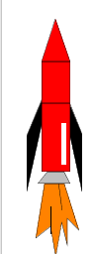  Write a story about your trip into space! Will you meet an alien? Be sucked into a black hole? Maybe save Planet Earth? | Joker Box Task  Create your own piece of English homework this week! | Make a model spacecraft using any materials you can think of.  