DO NOT HAND THIS SHEET BACK IN, YOU WILL NEED IT EACH WEEK!
Year 5 English homework
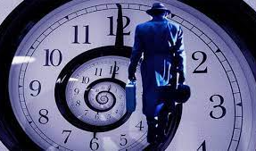

Time Traveller
Choose one activity below for each piece of English homework.
Draw and label a design for a product of the future. What would it do? How would it make life easier? | 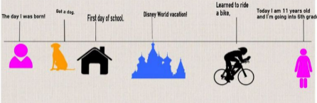  Look at some old family photographs. Create a timeline for your family showing the important events such as births, marriages or house moves. | Create portraits of members of your family. Will you draw, paint, or use photography or computer software?
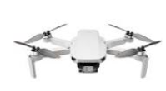  Do some research and then make an information leaflet about the most important technological inventions. Here are some suggestions: mobile phone, video games, electric cars, drones and the World Wide Web. Can you imagine life without them now? | Joker Box Task  Create your own piece of English homework this week! | 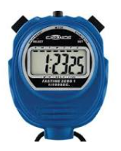  Time yourself doing different activities at home. Create a pie chart showing the proportion of time spent each day eating, sleeping, or at school.

