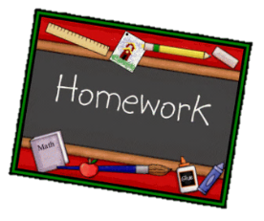
Year 4 English homework
Choose one activity below each week.
Please complete and put it into the homework tray every Thursday. We will look at work together in class and then the purple homework books will go home again on a Friday
.
At the bottom of your homework, ask an adult to sign and make a comment on your piece of work.

Have a Victorian evening – no computer, mobile phone, TV! You can dress up as a Victorian if you like too!  Write about how you found this experience. | Find a Victorian recipe (for example from Mrs Beeton)  Make the recipe and write a review of the food you ate. | Write a letter to a Victorian child who went to our school. What questions would you like to ask them?
Surprise me! Take a page in your book and do what you want! | Research the Royal Residences. Which Royal houses and palaces were used by Queen Victoria? | Find out about the life of a Victorian house maid. Write a job description.
Write 5 similes to describe the workhouse. | Imagine you are George Hammond Lucy or Mary Elizabeth Williams. Write an invitation inviting friends to a grand ball at Charlecote Park. | Research Victorian Christmas Traditions. What do we do at Christmas now that began in the Victorian Era?
Write a letter to your MP about an issue that concerns you. | Design and label a new outfit for a Victorian housekeeper. | Explain to someone at home what a subordinating conjunction is and what a coordinating conjunction is, give examples.
Year 4

