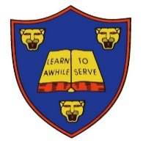
Stratford upon Avon Primary Planning – Medium Term copywrite@tparton2021
Year 5:
Spring Term 2021 – 2nd half
Lesson/Date | Week 1  28th February | Week 2  7th March | Week 3  14th March | Week 4  21st March | Week 5  28th March | Week 6  4th April
Visits/Visitors/  Other Info | 28th -Digital Leaders meeting/ job roles, photos  3rd World Book Day  3rd Stratford book competition  3rd Netball club  1st Pancake Day  3rd West End Workshop  4th EAL (LT) | 7th Digital Leaders meeting/badges, plan video 8th/9th Parents evening  7TH Computing CPD  11th March - Break the Rules  Dress Up Day  ECT-conference | 14th Digital leaders meeting- video, record and edit  15TH March Science Deep Dive  16th March - Heart of  England - Year 5 | 21st-digital leaders meeting/parent engagement  21st -27th Shakespeare week  Start Data collection  22nd Protective Behaviours training  23rd Shakespeare Workshop  24th/25th parents on for Shakespeare week | 28th digital leaders meeting/parent training incentive  31st March Humanities Deep Dive  31st Data in  30th Parent workshop/Tudor shields | 4th April digital leaders/Mash club intro for summer 1.
Spellings and GPS
 | Spelling rule:  22-Words containing the letter string ’ough’ where the sound is /o/ as in boat or ‘ow’ as in cow.  Recap Homework-Double Consonants | Spelling rule:  23-Adverbs of possibility. These words show the possibility that something has of occurring.  Recap Homework-Double Consonants | Spelling rule:  24-Challenge Words  Recap Homework-Double Consonants | Spelling rule:  25-These words are homophones or near homophones.  Recap Homework-Double Consonants | Spelling rule:  26-These words are homophones or near homophones.  Recap Homework-Double Consonants | Spelling rule:  27-These words are homophones or near homophones.  Recap Homework-Double Consonants
 | Sentences - Relative clauses  Relative Pronouns  Recognising relative clauses  Using relative clauses  Omitting relative clauses | Sentences – parenthesis  Recognising parenthesis  Using brackets to indicate parenthesis  Using dashes to indicate parenthesis  Using commas to indicate parenthesis | Sentence- expanded noun phrases  Recognising noun phrases  Creating concise noun phrases  Writing concise noun phrases  Using noun phrases | Sentence- Tenses  Past or Present?  Present perfect form  Recognising past perfect form  Using the past perfect form | GPS Spring assessment  Grammar and Year 5 common words Spelling Assessment  Compare spelling results with Autumn term. | Sentence – Tenses  Recognising the future perfect form  Using the future perfect form  Recognising the perfect form in sentences  Using the perfect form in sentences
English | Writing focus/ purpose: entertain/poetry  VIPERS  Subordinate/relative clauses  Children to use inference skills to make predictions based on the opening scenes of ‘The Tempest’  Explore the use of personification and the impact on the reader.  Children to look at similes.  Use personification and other figurative devices to write a poem/spell to conjure up a storm | Writing focus/ purpose: entertain/character descriptions  VIPERS  Adverbials/conjunctions  Children to use drama techniques to explore Prospero’s story and his relationships with other characters. They will then use a range of sentences to write about the different characters within the play.  Children to write a dairy entry showing Prospero’s opposing views towards Caliban and Ariel’s. Children to attempt to use some form of informal language in their writing. | Writing focus/ purpose: inform/explanation/discuss  VIPERS  Modal verbs/expanded noun phrases  Explore the use of impersonal language and the impact of this on the reader in preparation for non-fiction writing.  Children use speeches, word and phrases to explore if Caliban should be viewed as a Man or a Monster.  Discuss/balanced argument- A game of conscious alley will be played for wring response to the questions- Caliban: Man, or Monster?  Explanation-Children to produce a care manual for Caliban using impersonal style. | Writing focus/ purpose: entertain/narrative  VIPERS  Colon/dashes/commas  Sequel in the form of a dairy entry- either Caliban or Ariel, now that Prospero and Miranda have left the island.  Independent write- an extended dairy entry, taking note of DADWAVERS to improve sentences. | Writing focus/ purpose: entertain/narrative  Writing assessment  VIPERS  Relative clauses/expanded noun phrases  Sequel in the form of a dairy entry- either Caliban or Ariel, now that Prospero and Miranda have left the island.  Independent write- an extended dairy entry, taking note of DADWAVERS to improve sentences. | Writing focus/ purpose: discuss/review  VIPERS  Passive voice/adverbials for cohesion  Children to write a review of the ‘The Tempest’  Select a character to review  Create a green screen book review
Maths | Recap Unit: Fractions  -improper fractions to mixed numbers  - mixed numbers to improper fractions  -compare and order fractions less than 1  -compare and order fractions less than (2)  -compare and order fractions greater than 1 | Unit: Fractions  -add and subtract fractions  -add fractions within 1  -add 3 or more fractions  -add fractions  -add mixed numbers | Unit: Fractions  -subtract fractions  -subtract mixed numbers  -subtraction-breaking the whole  -subtraction 2 mixed numbers  -multiply unit fractions by an integer | Unit: Fractions  -multiply non-unit fractions by an integer  -multiply mixed numbers by integers  -calculate fractions of a quantity  -fraction of an amount | Unit: Fractions  -Maths assessment (a)  -Maths assessment (pr)  -using fractions of operators  -Fraction problem solving  -Fraction escape room | Unit: Decimals  -decimals up to 2 d.p  -decimals as fractions  -decimals as fractions  -Understanding thousandths  -Thousandths as decimals  -
Science | Science focus: Animals, including humans  Gestation | Science focus: Animals, including humans  Foetal development | Science focus: Animals, including humans  Growth and change: baby and child | Science focus: Animals, including humans  Growth and change: adolescence and puberty | Science focus: Animals, including humans  Growth and change: adults and old age | Science focus: Animals, including humans  Human timeline
ART/D & T | ART/D & T  Portraits  Look at portraits by Hans Holbein, including those of Anne Boleyn, Henry VIII and Thomas Cromwell. Discuss their features, including posture, colour and other interesting details. Compose questions about each individual inspired by the portraits. | ART/D & T  Miniature Portraits  Look at a number of miniature Tudor portraits, exploring the expression of the subject and how the composition is arranged. Practise painting small details using fine brushes and magnifying glasses. Evaluate and refine techniques to paint a miniature, Tudor style portrait based on a photograph of themselves. | ART/D & T  Photo Booth  Shakespeare photo booth - creating photo booth props, based on Shakespeare characters, e.g. rose, skull, dagger and a photo frame so visitors on the day can come in, dress up and have their photo taken by Reuben! | ART/D & T  Costumes and Jewellery  Make detailed observational sketches of Tudor costumes and jewellery. Consider the fabrics and materials used and create a collage or scrapbook using drawings, fabric samples, notes and printed images from the web. Make detailed sketches, then use pencil, pens or paint to pick out rich detail.  Photo | ART/D & T  Parent workshop- Tudor Shields  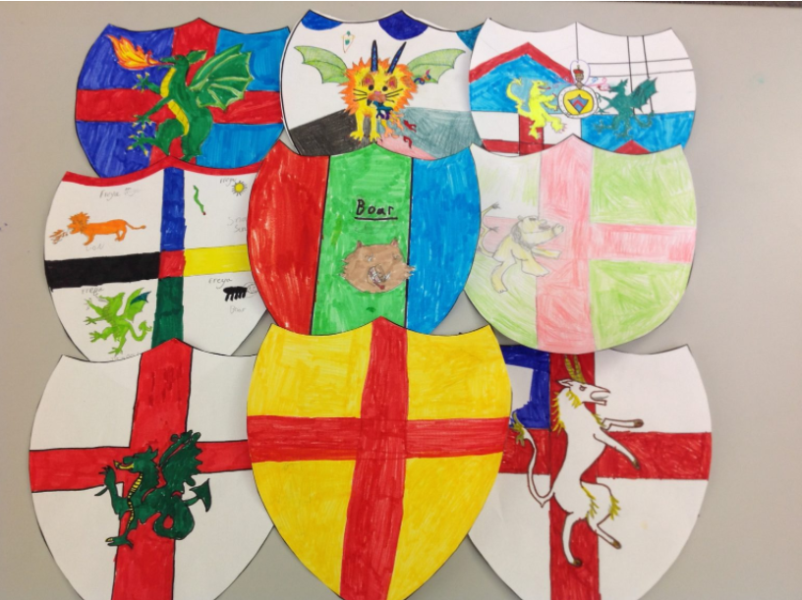 | ART/D & T  Tudor Bread  Make Tudor bread.  Tudor knot gardens  Draw and create a Tudor Knot garden.  Use lines of symmetrical patterns.
Topic | Topic: History-  Tudor Timeline  Use a range of source materials to sequence a Tudor timeline, from the Battle of Bosworth (1485) to the death of Elizabeth I (1603), explaining where the Tudors fit into our history. | Topic: History-  Tudor Visit  Visit a local Tudor building or museum or interview a historical expert and find out how the local area was influenced or changed during Henry VIII’s reign. Plan questions, listen to speakers and make notes. Summarise their learning in a recount about their visit, including drawings and photographs to illustrate. | Topic: History-Tudors  Henrys Marriages  Create a timeline of Henry VIII’s marriages and generate research questions, such as ‘Why did he marry six times?’ and ‘Which was his longest marriage?’ Record these on a research wall for exploration. Create individual illustrated timelines using appropriate software. | Topic: History-Tudors  Henry’s Homes  Use the web and other historical sources to find out where Henry VIII lived during his lifetime and locate these places on a UK map. Look at one of these homes in detail, making a map and a plan for it and sketching detailed illustrations of the palace or house. | Topic: History-Tudors  Tudor Punishment  Work in teams to find out about Tudor crimes and punishments. Create illustrated mind maps to record their findings, adding facts, diagrams and illustrations, then share their findings with others to compare. Give their view of the punishments of the time. | Topic: History-Tudors  Treason  Discuss the meaning of this quote by Anne Boleyn’s uncle, the Duke of Norfolk, as he passed judgement on her in court:
PE | Tuesday: Pancake Race/Rounders  Thursday: Tag Rugby | Tuesday: Rounders  Thursday: Tag Rugby | Tuesday: Rounders  Thursday: Tag Rugby | Tuesday: Rounders  Thursday: Tag Rugby | Tuesday: Rounders  Thursday: Tag Rugby | Tuesday: Rounders  Thursday: Tag Rugby
Music-Charanga | Charanga: Lean on me  Step 1 Listen and appraise Billy Withers | Charanga: Lean on me  Step 2 Listen and appraise- He still loves me | Charanga: Lean on me  Step 3 Listen and appraise -Shackles (Praise you) by Mary Mary | Charanga: Lean on me  Step 4 Listen and appraise -Amazing Grace by Elvis Presley | Charanga: Lean on me  Step 5 Listen and appraise-Ode to joy | Charanga: Lean on me  Step 6 Listen and appraise -Lean on me by ACM gospel choir
Computing-Purple Mash | Unit 5.8 Word Processing  Making a Document from a Blank Page  • Children know what a word processing tool is for.  • Children will be able to create a word processing document altering the look of the text and navigating around the document. | Unit 5.8 Word Processing  Inserting Images: Considering Copyright  • Children know how to add images to a word document.  • Children can edit images to reduce their file size.  • Children know the correct way to search for images that they are permitted to reuse.  • Children know how to attribute the original artist of an image. | Unit 5.8 Word Processing  Editing Images in Word  • Children can edit their images within Word to best present them alongside text.  • Children understand wrapping of images and text. | Unit 5.8 Word Processing  Adding the Text  • Children can add appropriate text to their document, formatting in a suitable way.  • Children can use a style set in Word.  • Children can use bullet points and numbering. | Unit 5.8 Word Processing  Finishing Touches  • Children can add text boxes and shapes.  • Children can consider paragraph formatting such as line spacing, drop capitals.  • Children can add hyperlinks to an external website.  • Children can add an automated contents page. | Unit 5.8 Word Processing  Writing a Letter Using a Template  • Children can use a Word template and edit it appropriately.
RE-  SACRE | Unit u2.2 What would Jesus do?  Big question: Which people are special and why?  Love: use some of Jesus’ stories, teachings and example to understand what Christians believe he meant by loving others. | Unit u2.2 What would Jesus do?  Big question: Which people are special and why?  Love: Luke 15:11–32; love your enemies, Matthew 5:43–48; compare Paul’s letter, 1 Corinthians 13:4–7; explore the idea of agape love – self-sacrificial love; make link with belief that Jesus died to show his love for all humans, John 3:16). | Unit u2.2 What would Jesus do?  Big question: Why is Jesus inspiring to some people?  Forgiveness: use some of Jesus’ stories, teachings and example to understand why he saw forgiveness as so important. | Unit u2.2 What would Jesus do?  Big question: Why is Jesus inspiring to some people?  Justice and fairness: use some of Jesus’ stories, teaching and examples to understand the  way Christians believe we should treat each other. | Unit u2.2 What would Jesus do?  Big question: what is so radical about Jesus?  Generosity and not being greedy: use some of Jesus’ stories, teaching and examples to understand the way Christians believe we should handle wealth. | Unit u2.2 What would Jesus do?  Big question: what is so radical about Jesus?  Read gospel passages that talk about the ‘kingdom of God’, where people live the way God wants people to live. What would this kingdom be like?
PSHE-Jigsaw | Unit: Healthy Me  Smoking: I know the health risks of smoking and can tell you how tobacco affects the lungs, liver and heart.  I can make an informed decision about whether or not I choose to smoke and know how to resist pressure | Unit: Healthy Me  Alcohol: I know some of the risks with misusing alcohol, including anti-social behaviour, and how it affects the liver and heart.  I can make an informed decision about whether or not I choose to drink alcohol and know how to resist pressure | Unit: Healthy Me  Emergency Aid: I know and can put into practice basic emergency aid procedures (including recovery position) and know how to get help in emergency situations.  I know how to keep myself calm in emergencies | Unit: Healthy Me  Body Image: I understand how the media, social media and celebrity culture promotes certain body types.  I can reflect on my own body image  and know how important it is that this is positive and I accept and respect myself for who I am | Unit: Healthy Me  My relationship with food:  I can describe the different roles food can play in people’s lives and can explain how people can develop eating problems (disorders) relating to body image pressures.  I respect and value my body | Unit: Healthy Me  Healthy me: I know what makes a healthy lifestyle including healthy eating and the choices I need to make to be healthy and happy.  I am motivated to keep myself healthy and happy
MFL-French | Recap numbers 1-20  Learn how to pronounce the alphabet in French. | Recap days of the week  Be able to recite numbers to 31. | Recap months of the year  Be able to list the months of the year and be able to discuss their own birthdays and those of their friends. | Recap colours  Learn about pets and discuss and compare likes and dislikes. | Recap name and age  Learn about the use of masculine and feminine and learn how to make adjectives agree with nouns they are describing. | Recap numbers 1-31  Learn the verbs avoir and etre.

