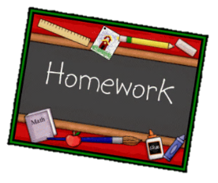
Year 1 English homework Autumn 2
Choose one activity below for each piece of English homework.
Complete work in your homework book. Remember to put it into the homework tray by the due date for marking (always on a Wednesday):
14th November, 28th November, 12th November
Creative tasks and joker box tasks can be completed on additional paper if needed. Please ask if you need anything else.
At the bottom of your homework, ask a grownup to sign and make a comment on your piece of work.

Plan a healthy lunchbox for a superhero. | Make up a song or a rhyme about a superhero.  What are their strengths/super powers? | Who is your hero? Write a paragraph explaining who your hero is and why. It doesn’t have to be a superhero, it could be someone you know.
If you had a superpower what would it be? | Take pictures of yourself being a ‘superkid’ at home. It could be of you tidying your room or helping someone in your family. | Write five questions you would ask Spiderman.
CREATIVE TASK 1  Create a poster for your favourite superhero. | JOKER BOX  Make up your own piece of English homework. Try to link it to our work in the classroom. | CREATIVE TASK 2  Make a model of a superhero.

