**Spirituality**

**A thread running through the curriculum, making thought provoking links:**

Using our Welly Wednesday session to show appreciation and respect for our beautiful natural environment and the creatures and wildlife within it.

**Maths**

**This term in Numbers we are focusing on:**

Saying the number one more or one less than a given number

Record using marks we can interpret and explain

Use quantities and objects to add and subtract two single digit numbers

Count reliably with numbers one to twenty and place them in order

**This term in Shape, Space and Measure we are focusing on:**

Selecting a particular named shape

Order items by weight, length, height and capacity

Recognise create and describe patterns

**English**

**This term we are reading fiction and non-fiction farm books**

Key Texts: farm information books, A Squash And A Squeeze, Farmer Duck, What The Ladybird Heard, Rosie’s Walk

**Exploring these texts will enable us to:**

Use a pencil and hold it effectively to form recognisable letters most of which are correctly formed

Knows that information can be retrieved from books and computers

Enjoy an increasing range of books

Write labels and captions

Write short sentences in meaningful contexts

**Communication and Language**

**This term we will be focusing on children:**

Listen attentively in a range of situations

Listen and respond to ideas expressed by others in conversation and discussion

Extending vocabulary, especially by grouping and naming, by exploring the meaning and sound of new words

Linking statements and sticking to main theme and intention

**Expressive Arts and Design**

**Through taking part in a range of creative based activities we will:**

Select tools and techniques needed to, shape, assemble and join materials they are using

Play cooperatively as part of a group to act out and develop a narrative

Create simple representations of events, objects and people

Do cows drink milk?

Curriculum Plan – Spring Term 2 2018

Reception: Miss Gill

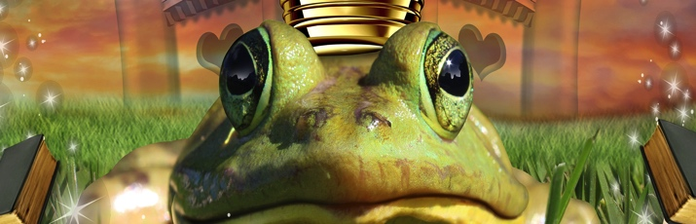

**Understanding The World**

**We will:**

Understand that other children don’t always enjoy the same thing and are sensitive to this

Learn about the similarities and differences in relation to places, objects, materials and living things

Make observations of plants and animals, explain why some things occur and talk about changes

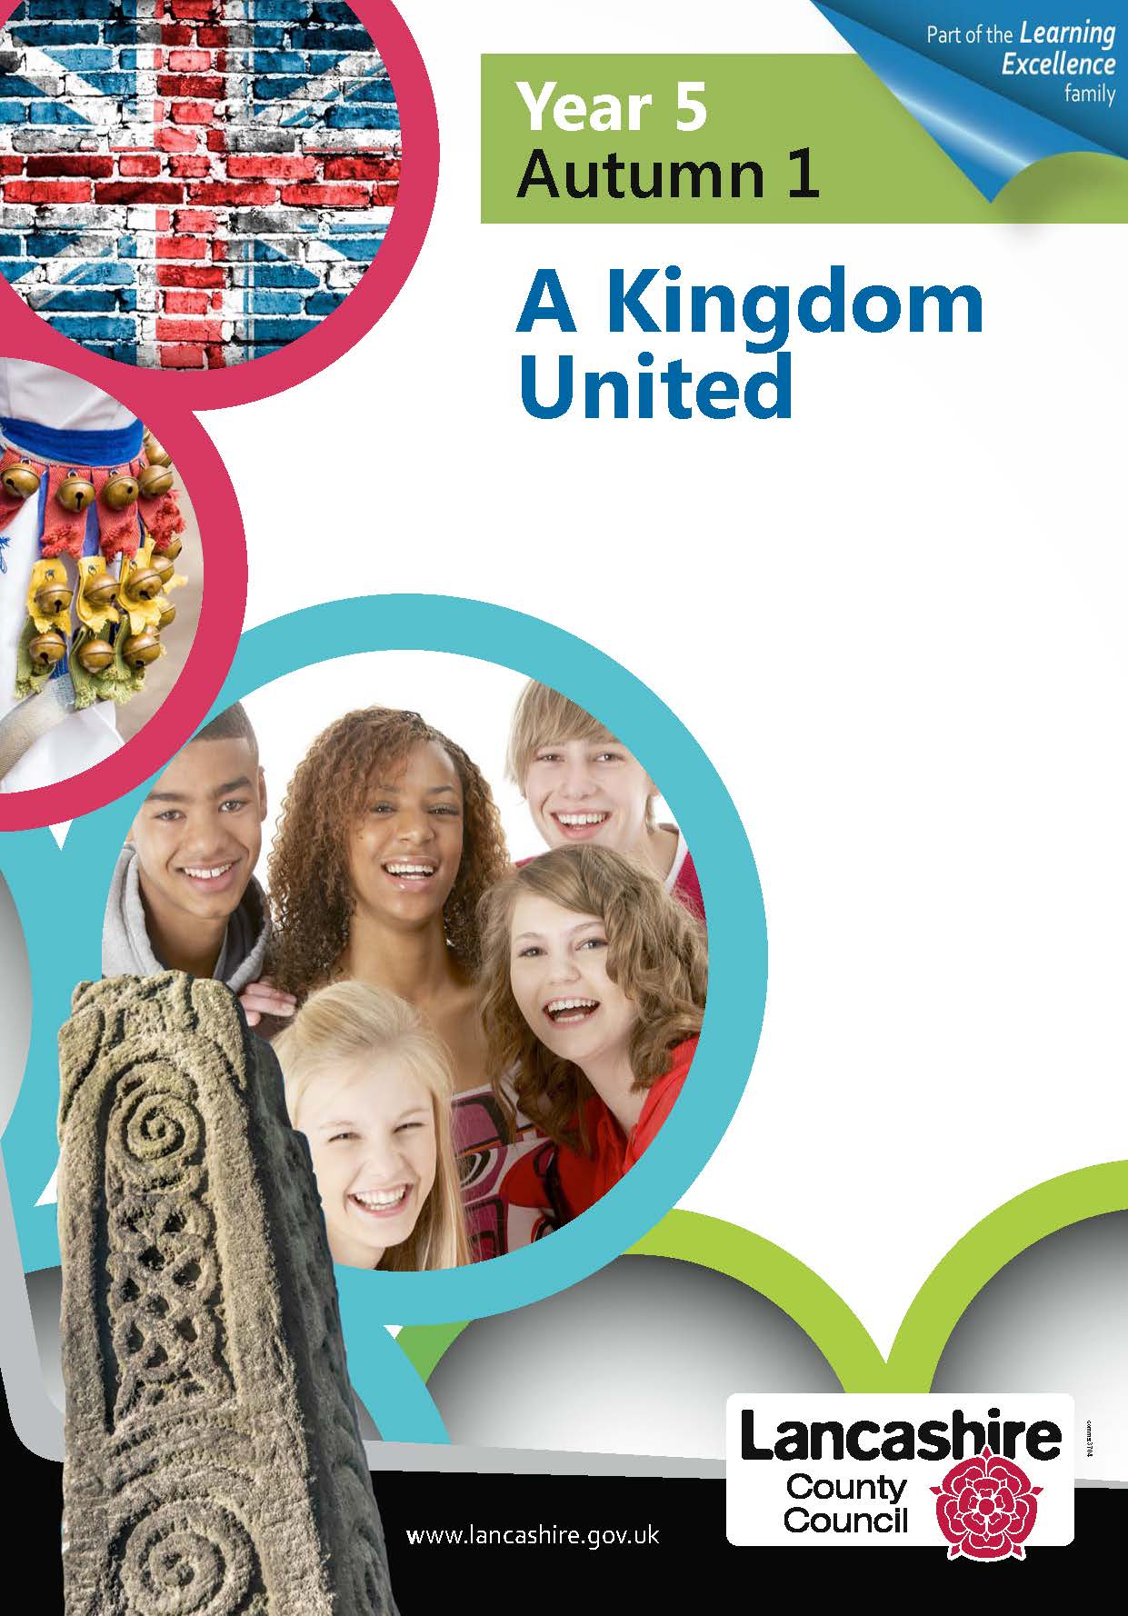

 



**Personal Social and Emotional Development**

**This term we will be encouraging children to:**

Take steps to resolve conflicts with other children

Confident to speak to others about own needs, wants, interests and opinions

Beginning to be able to negotiate and solve problems without aggression, e.g. when someone has taken their toy

**Super Start: World Book Day**

**Fantastic Finish: Taking a school trip to a farm**

**British Values**

**We will learn about Fundamental British Values with the help of Yoimoji.**

Pip Puppet will help us learn about the concept of bravery, explore examples of bravery and how to be brave.

Fizz Puppet will help us learn how to be kind, exploring examples of kind words and actions, and how they make us feel

Through daily discussions and set circle time we will embed these values in the classroom.

**Physical Development**

Travel with confidence and skill around, under, over and through balancing and climbing equipment

Show increasing control over an object in pushing, patting, throwing, catching or kicking it

Know the importance for good health of physical exercise, and a healthy diet and talk about ways to keep healthy and safe