

**Develop your creativity:**

**Each DEPTH 3 points**

* Create a storm in a box: use any objects/materials you like to create a storm.

**DUE 9th March for our science display**

* Design a Shakespeare set for *The Tempest*.

DEPTH points will convert to House Points.

*Tick off what you have completed to achieve your points and bring your work into school on the above date*

This half term’s DEPTH is:

**Splendid Skies**

Hand in: Monday 26th March

**Explore your science skills.**

**Each 3 DEPTH points**

* Play this weather report game:

<http://www.bbc.co.uk/schools/barnabybear/games/weather_report.shtml>

* Collect rainwater in a container. How much can you collect in one week? Draw a graph to show your findings.

|  |
| --- |
| * Go on a walk, taking photographs   of signs of the season, such as  buds, new leaves or leaves falling  from the trees. |

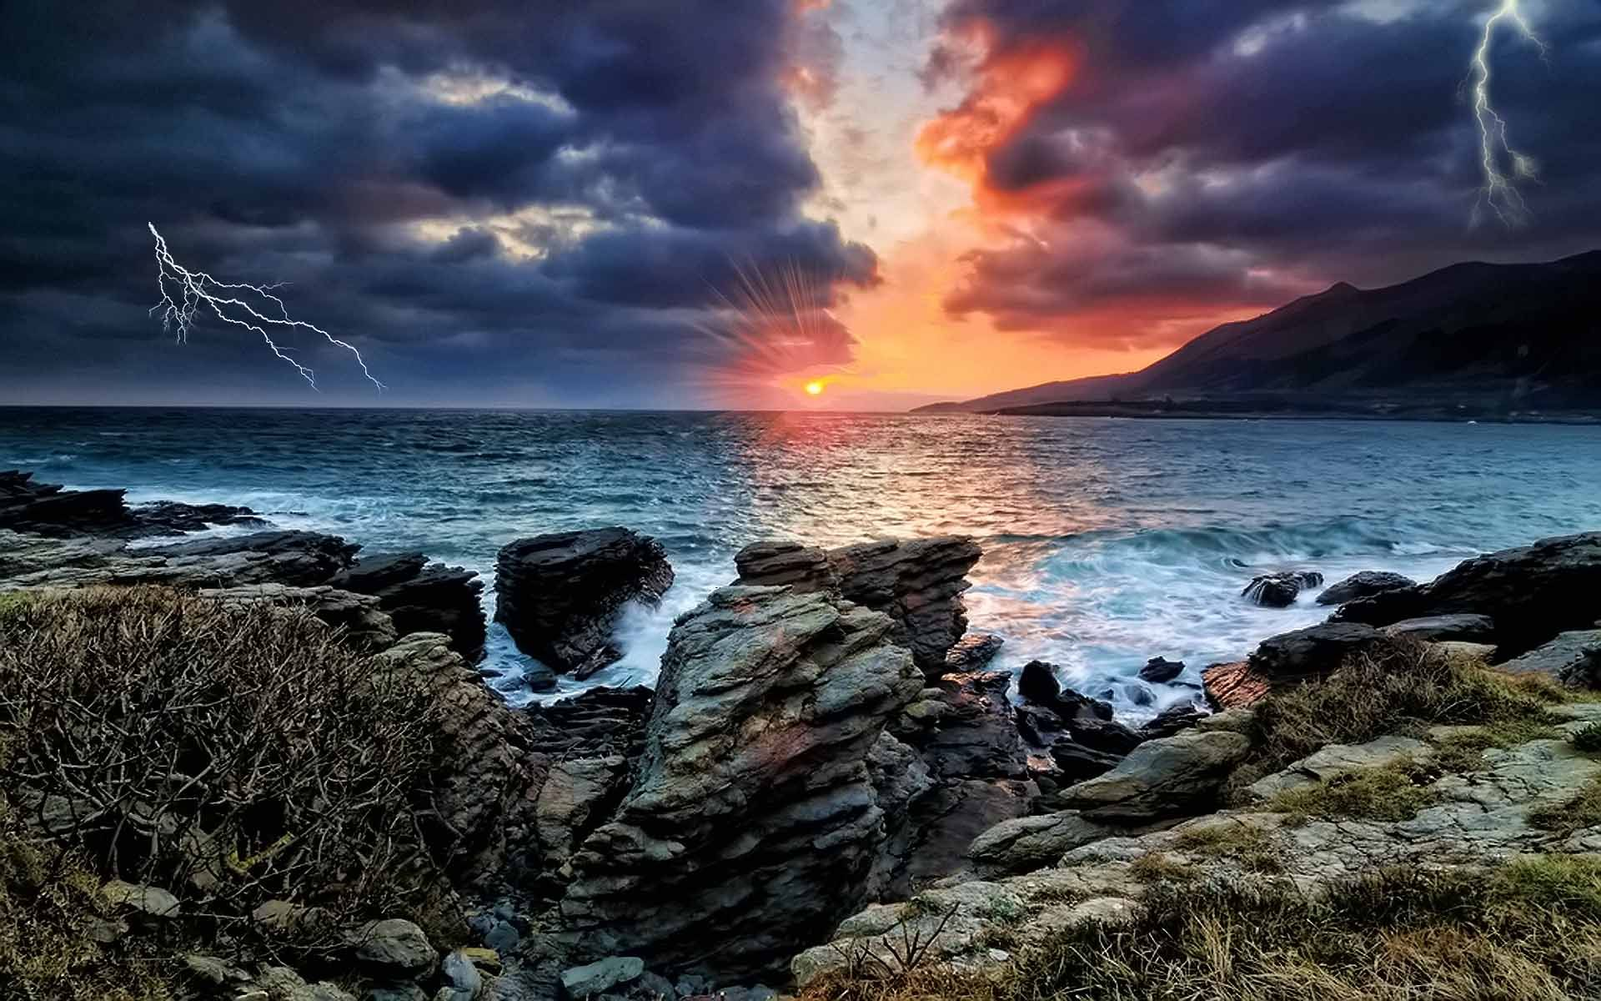

**Explore your writing skills:**

**Each 3 Depth Points**

* Learn how to spell weather words such as rain, wind, snow, sun, storm, wet, dry, hot and cold.
* Make a weather/seasons poster with labels and captions.
* Visit your local library to look for stories about the weather. Draw a story map for one you enjoyed.

**Extend your research skills:**

**Each 3 DEPTH points**

* Visit your local library with an adult and search for non-fiction, fiction or poetry books about the weather.
* Find out about countries that experience the worst weather conditions. Write down some facts you found.