Year 1 English homework Rio De Vida

Choose one activity below each week.
Complete and put it into the homework box every Monday.
Please ask if you need any more details or resources.
At the bottom of your homework, ask an adult to sign and make a comment on your piece of work.
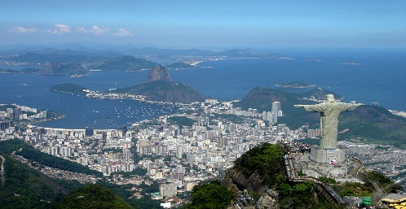

Watch the film Rio and write a character description for your favourite animal. | Choose 5 words from the spelling list. Learn them and then write a sentence for each one. | Create an ‘Amazing Rio’ scrapbook with facts you’ve found out about Brazil and its capital city.
Find out about some Brazilian sports stars- you could choose Pele, Neymar or Ayrton Senna. Write their Biography | https://www.dkfindout.com/uk  Use the web-link and search ‘Rio’ to read about Christ the Redeemer statue and the Olympics in Rio. | Imagine you’re on holiday in Rio during the carnival. Write a diary entry including how your felt and the sights and sounds you experienced.
Create a fact file for a Brazilian football player | Design your own carnival float. What characters, animals or decorations would you choose? Make a labelled drawing of your ideas using lots of vibrant colours! | Read a Brazilian recipe and try making one with your family.
Children need to learn the words on the spelling list and these will be assessed using their independent writing tasks.
Summer 1 Spellings
of
is
they
no
there
once
pull
people
think
when
where

