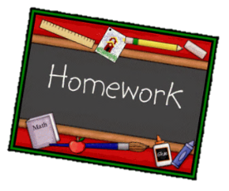
Year 2 English homework
Choose one activity below each week.
Complete and put it into the homework tray every Monday.
Plain paper, lined paper and book review templates can be picked up next to the homework tray. Please ask if you need anything else.
At the bottom of your homework, ask a grownup to sign and make a comment on your piece of work.

Create a dragon poem, you could describe it or tell a story about it. | Draw a picture of a dragon. Write a description on what it looks like and what it can do. |  | Write a book review on a book which has a dragon as a character.
Choose 6 words from the spelling list. Learn them and then write a sentence for each one. | Find out about St George – write a short story about his battle with a dragon!  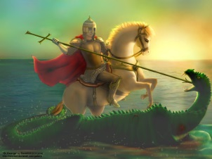 |  | Choose 5 homophones (words that sound the same but are spelt differently – flower/flour)  Put them into sentences showing what they mean.
Copy a few sentences from your reading book, Underline  - Nouns in red (naming words)  - Verbs in blue (doing words)  - Adjectives in green (describing words) |  | Research about an amazing structure from around the world, e.g The Statue of Liberty, Stonehenge, The Great Wall of China. Write a postcard imagining you have visited the structure as part of a holiday. What was it like?
Imagine you are locks in a dungeon. Write a plan on how you will escape. | Imagine what a day in a castle would be like. Write a diary entry on what you got up to. |  | Research about a famous castle. Write 5 interesting facts you have found.
Children need to learn the words on the spelling list for a spelling test week commencing Monday 18th December (see the list on the back)

Autumn 2 spellings
Floor
Behind
Only
Everybody
Beautiful
Grass
Move
Could
Many
Half

