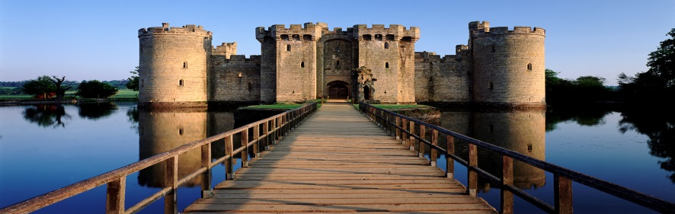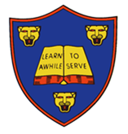

**Explore your writing skills:**

* Make an information booklet about castles, bridges or tunnels. Include pictures, drawings and fascinating facts.
* Read a fairytale set in a castle. Use it as inspirtation to write your own story based in a castle.

**Explore your investigation skills:**

* Play a tumbling tower game such as Jenga with your family. Record what the best ways of keeping the tower upright are. See if you can take some action shots of the tower falling!
* Make a biscuit bridge. Plan a fair test to find out which biscuit is the strongest and makes the best bridge. Record your results showing the best to worst bridge.

**Develop your creativity:**

* Make a detailed diagram of a castle, labelling interesting features which might be found inside or out.
* Design and create a model of a famous structure from around the world using junk materials.
* Design a fantastic new landmark for your local area. What materials would you use and what special features would it have?

**Extend your research skills:**

* Find out about famous engineers. Find out about their life and work. Draw a picture to show one of their most famous achievements.
* Go on a bridge hunt with a grown up. What types of bridge did you see? Take photos of them and place them on a map.

This half term’s DEPTH is:

**Towers, Tunnels and Turrets**

Hand in: Monday 18th December

Children should complete 1 or 2 pieces of depth work.

Children will present their work to the class where they can be awarded up to 10 stars in total.