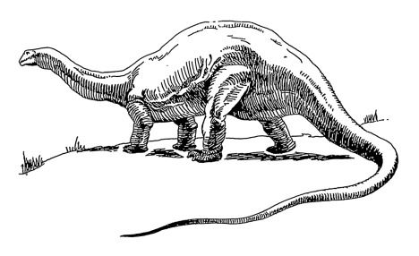

**Explore your science skills.**

**Each 3 DEPTH points**

* Play this game: <http://www.sheppardsoftware.com/scienceforkids/dinosaurs/games/appetite/dinomight_appetite.htm> to find out about what different dinosaurs ate.

|  |
| --- |
| * Write a dinosaur quiz to test your   friends and families dino  knowledge! |

**Develop your creativity:**

**Each DEPTH 3 points**

* Create a Jurassic world painting
* Make your favourite dinosaur

DEPTH points will convert to House Points.

*Tick off what you have completed to achieve your points and bring your work into school on the above date*

This half term’s DEPTH is:

**DINOSAUR PLANET**

Hand in: Monday 21st May

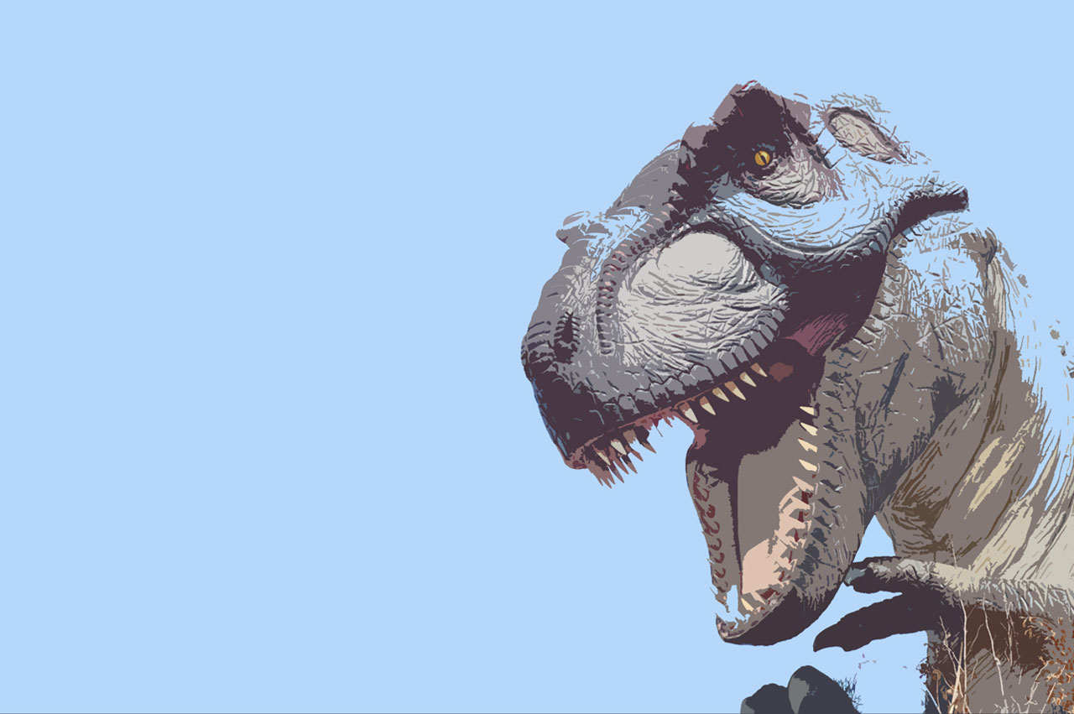

**Explore your writing skills:**

**Each 3 Depth Points**

* Practise spelling dinosaur names. Why not create new ones?
* Write a dinosaur story or non-fiction book
* Visit your local library to look for non-fiction texts about dinosaurs,

**Extend your research skills:**

**Each 3 DEPTH points**

* Use the internet to find out more about when dinosaurs lived and how they became extinct.
* Use a map to discover which continents dinosaurs lived in - can you create your own map?