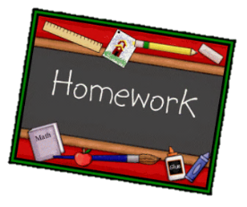
Year 1 English homework Dinosaur Planet

Choose one activity below each week.
Complete and put it into the homework box every Monday.
Please ask if you need any more details or resources.
At the bottom of your homework, ask an adult to sign and make a comment on your piece of work.
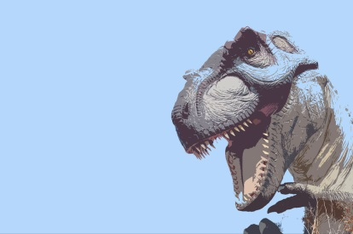

Write s story about ‘A day with a dinosaur’. Include the fun things you would get up to with your favourite dinosaur and the mischief you might cause. | Choose 5 words from the spelling list. Learn them and then write a sentence for each one. | Design a new species of dinosaur. Write labels and captions to explain the features they would have.
Find out what 3 different dinosaurs would have eaten. Are they herbivores, carnivores or omnivores? | Use DK Find out (link on our class page) to write about the history of dinosaurs. | Write a poem with the title ‘Dancing Dinosaur’ Use alliteration and rhyme
Create a top trump card for your favourite dinosaur  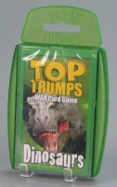 | Try to write 5 dinosaur names using only your phonics knowledge - Have you spelt them correctly? Are they spelt how they sound? | Write compartive sentences for two dinosaurs.  E.g. A T-rex is taller than a Stegosaurus.  aaaaaaaaaaaaaa
Children need to learn the words on the spelling list and these will be assessed using their independent writing tasks.
Summer 1 Spellings
today
was
your
we
here
one
push
what
friend
of

