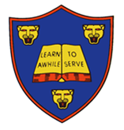

**Extend your research skills:**

* What qualifications and training do you need to become a dentist? You could quiz your dentist at your next appointment.
* What animal has the largest teeth? What animal has the smallest teeth?
* Drop grubby copper-plated coins into a range of fizzy drinks and leave them overnight to see what happens. Which brand has the most powerful cleaning properties?
* What foods are kind to your teeth?
* Research taste buds, where are they found in your body? What do they do?



**Explore your creative skills:**

* Can you make a sugar free cake or recipe? Bring your creation into school or take pictures as evidence!
* Create a model of a tooth or your mouth.

**Develop your writing skills:**

* Write an advert, telling people how they should look after their teeth. Remember to use persuasive writing!
* Write an explanation about how sugary foods can lead to tooth decay.
* Create a fact file about teeth, it could be human teeth or animal teeth or both.

This half term’s DEPTH is:  
**Burps, Bottoms and Bile**

Hand in: Monday 26th March

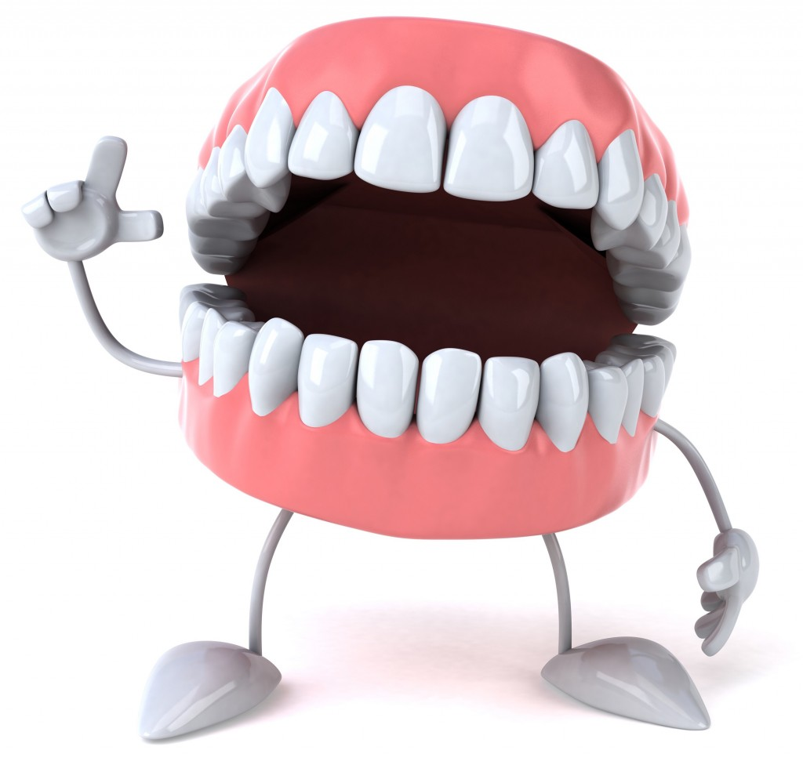

**Children are to pick a maximum of two activities to complete and bring into school.**

**They will be awarded up to 10 stars for both completed pieces of work.**