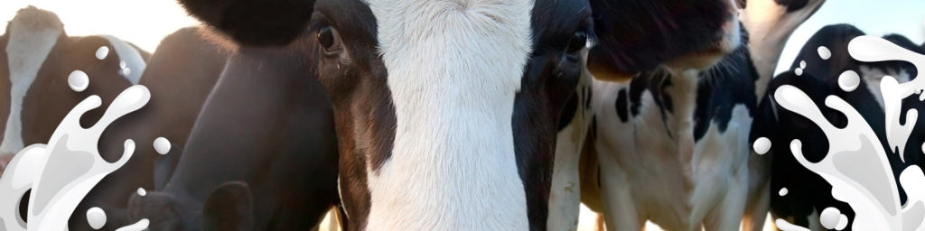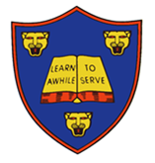§

This half term’s DEPTH is:

**Do Cows Drink Milk?**

Hand in: Monday 26th March

**Extend your singing skills:**

Use the tune of London Bridge is falling down to create a new song. For example, “this is how we milk the cow.” Can you come up with different verses to make a whole song?

**Develop your writing skills:**

Help your grown up unpack the shopping. Look at the items of food that have been brought, can you read the label or any of the ingredients on the packaging?

Can you make a list of the items that you think were grown on a farm?

How many did you find?

**Develop your Maths skills:**

The hens have laid their eggs! Can you hide up to 20 boiled eggs in your garden? Ask your child to find them and use the words ‘first’ ‘second’ and ‘third’ when they collect them. You could also number the eggs and put them in order from 1-20. Challenge yourself to 30!

**Explore your creativity:**

Have some fruits and vegetables and ask an adult to stick a fork into each half. Press the fruit or vegetable into a thin layer of paint and then press it into paper to make different fruity patterns. Talk about the different shapes, what happens when different colours run into each other or are printed on top of each other.

Completing two projects will achieve:

**10 Stars on your Star Card**