Maths
Developing confidence and mental fluency with whole numbers, counting and place value. Using accurate mathematical vocabulary. (bold Y2)
Number- Place Value
Recognise and use the inverse relationship between addition and subtraction and use this to check calculations and solve missing number problems.
Measurement – Money
Recognise and use symbols for pounds (£) and pence (p); combine amounts to make a particular value.
Find different combinations of coins that equal the same amounts of money.
Solve simple problems in a practical context involving addition and subtraction of money of the same unit, including giving change.
Number – Multiplication and Division
Recall and use multiplication and division facts for the 2, 5 and 10 times tables, including recognising odd and even numbers.
Calculate mathematical statements for multiplication within the multiplication tables and write them using the multiplication (x) and equals (=) sign.
Solve problems involving multiplication using materials, arrays, repeated addition, mental methods and multiplications, including problems in contexts.
Show that the multiplication of two numbers can be done in any order (commutative).

English
Reading - Key text: Zog by Julia Donaldson, The Snow Dragon by Vivian French, The Knight and the Dragon by Tomie DePaola. A range of appropriate nonfiction texts and online research.
Developing pleasure and motivation to read. Word reading and comprehension skills through class texts and reading sessions and written activities. (Weekly skills building)
Discussing texts and drawing inferences. Choosing own texts and sustained reading for pleasure.
Speaking and Listening: discussion and presentation during topic work
Writing Composition - Writing for different purposes, developing stamina, editing and checking work throughout.
Narrative: Writing a story, writing a letter, writing a recount, story mapping
Nonfiction: Presenting information in non-chronological reports linked to topic
Spelling: Weekly spellings to support National Curriculum spellings for Year 2
Grammar: Linked to the National Curriculum requirements for Year 2
Handwriting: Children join and enhance the fluency and neatness of their writing.
Emphasis on neat presentation and pride in all written work.
Computing
Promoting logical, creative thinking linked to other curriculum areas including maths and science. Computer programming skills and digital literacy.

Drawing software to create castles.

Science
Broaden scientific understanding of the world through exploration, observation, research and testing in the topic area of Everyday Materials
- Does the weight of a projectile thrown at a castle wall affect the damage done to it?
- Why are bridges shaped in different ways?
- Which biscuit is the strongest and makes the best bridge?

Spirituality
A thread running through the curriculum, making thought provoking links:
- Invoke a sense of awe and wonder about out local environment
- Exploring the past and how the environment has shaped our community
- Marvelling at the wonders of the world and God's creation through even the smallest creatures

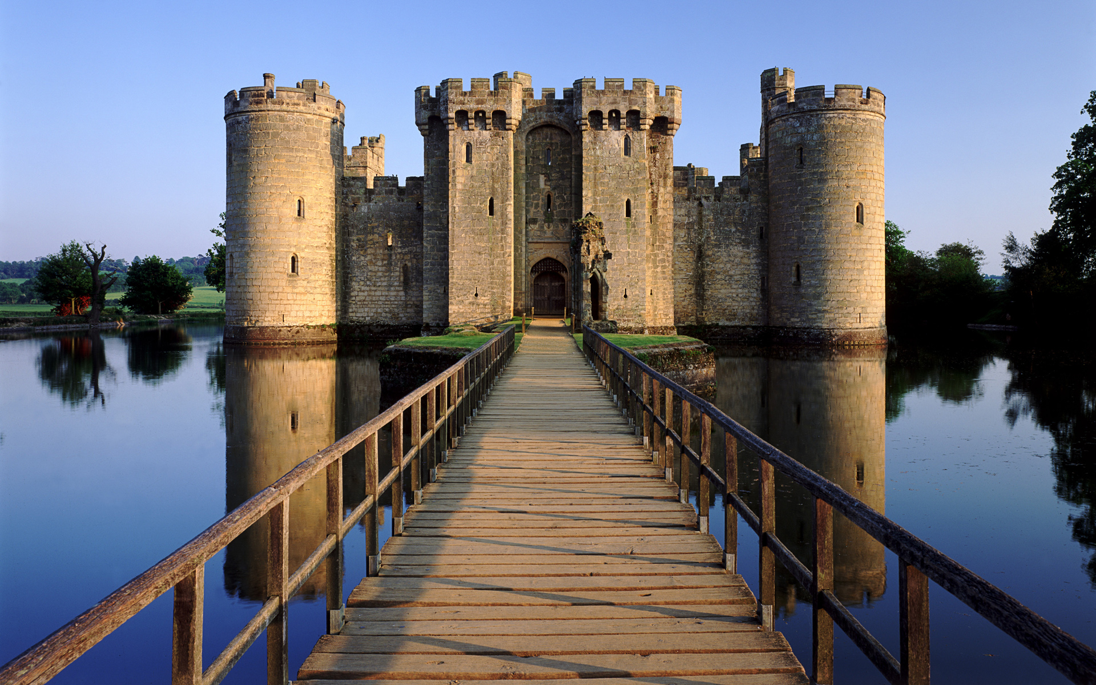
Music
Developing creativity and appreciation and a love of music
- Feel the pulse

Art
Use drawing, painting and sculpture to develop and share their ideas, experiences and imagination.
- Design and paint a shield
- Watercolour drawings of castles – ‘Castle and Sun’ by Paul Klee

Religious Education
Learning through thoughts, feelings and experiences about and from religions
Key Questions:
- Giving of presents
Look at why we give and receive presents.

Towers, Tunnels and Turrets
Curriculum Plan –Autumn 2017
Year 2
Miss O’Connell

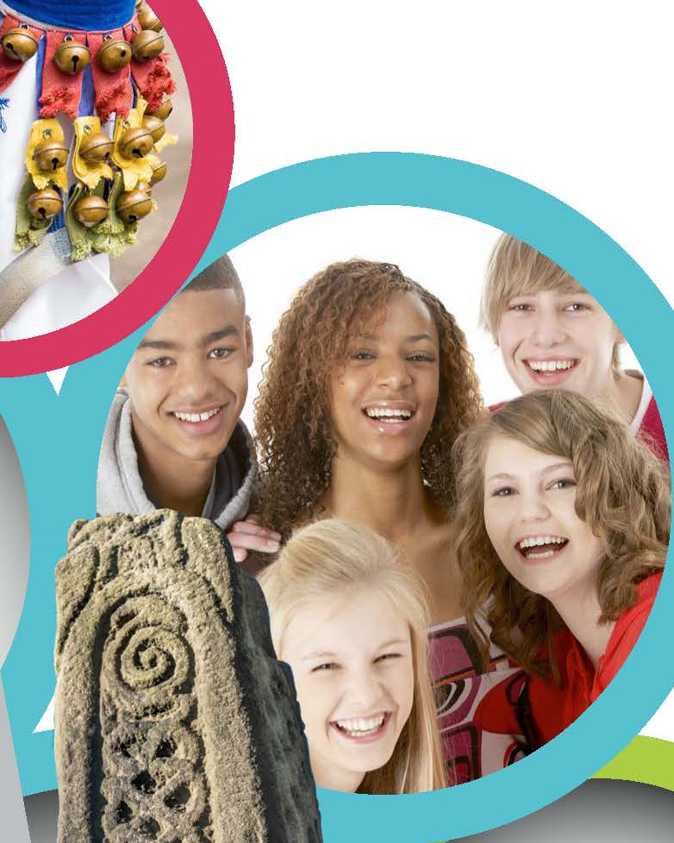
Design and Technology
Select from and use a wide range of materials and components, including construction materials, textiles and ingredients, according to their characteristics.
Select from and use a range of tools and equipment to perform practical tasks.
- Exploring, designing and making a castle model with a working drawbridge.

Super Start: Finding a dragon egg
Fantastic Finish:
Visit to Tamworth Castle
Christmas play

Physical Education
Developing movement skills, competence, agility and coordination individually and with others across a range of physical activity

Games – Unit 2 - Making up games with a partner
To remember, repeat and link combinations of skills in a game, to improve the co-ordination, control and consistency of their actions.

Dance – Unit 4 – to copy and perform simple movements, understand that dance plays an important part in other cultures and throughout history.
British Values
Developing an understanding of fundamental British values
Throughout the curriculum we will seek to promote the values of democracy, the rule of law, individual liberty and mutual respect and tolerance of those with different faiths and beliefs. Focus on democracy and the pupil voice (councils).

History
Learn about events beyond living memory that are significant nationally or globally.
Learn about the lives of significant individuals in the past who have contributed to national and international achievements.
- Research how castles have changed over time.
- Visit a castle.
- Look at what life was like for people in castles.
Geography
Use world maps, atlases and globes to identify the UK and its countries, as well as the countries, continents and oceans studied at this key stage.
Use basic geographical vocabulary to refer to key human features, including: city, town, village, factory, farm, house, office, port, harbour and shop.
- Identify the location of different castles around the UK.
- Explore why castles were built where they were.

PSHE
Anti bullying week
Getting on and falling out

Dilemmas
Making discussions.

