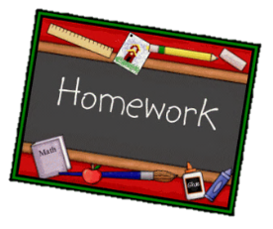
Year 2 English homework
Choose one activity below each week.
Complete and put it into the homework tray every Monday.
Plain paper, lined paper and book review templates can be picked up next to the homework tray. Please ask if you need anything else.
At the bottom of your homework, ask a grownup to sign and make a comment on your piece of work.

Research about marching bands.  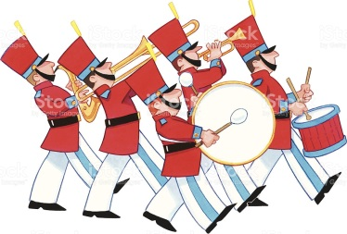  Write 5 facts. | Write a poem describing a piece of music. You could include how it makes you feel, what it sounds like.
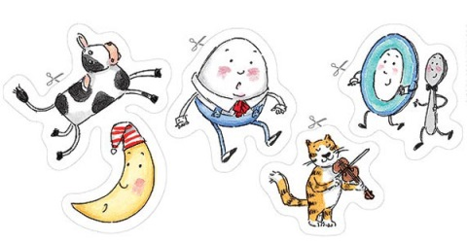  Copy your favourite nursery rhyme. Change a few words to make it your own, e.g. instead of The Grand Old Duke of York, you could have The Grand Young Queen of Kent. | Pick a nursery rhyme and re-write it as a short story.
In you reading book, look for past tense word. Write a list and then put them into your own sentence. | Create a fact page about percussion instruments. You could include information about where it originated from, what it looks like and how you play it.
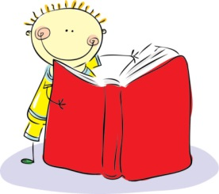  In your reading book, look for examples of these different sentence types:  - Command  - Statement  - Exclamation  - Question |  | Choose 6 words from the spelling list. Learn them and then write a sentence for each one.
Children need to learn the words on the spelling list for a spelling test week commencing Monday 26th March (see the list on the back)

Spring 2 spellings
Because
Children
Old
Great
Last
Plant
Improve
Would
Busy
Mr/ Mrs

