

**Extend your research and scientific skills:**

* Find out why the ocean is blue.
* How many amazing shark facts can you find? Create a presentation to show the class.
* Create a top trumps set of cards for under the sea animals.
* Research a famous under the Sea Explorer and create a profile on them e.g. Robert Ballard, Sylvia Earle, William Beebe and James Cameron.
* Research the different layers of the ocean and create a diagram to show the class what animals live in each layer.
* Research and create a presentation on your favourite under the sea animal.

**Develop your writing and creative skills:**

* Write a ‘true or false’ quiz with fascinating facts about creatures and plants under the sea.
* Create a 3D model of an under the sea animal.
* Create a picture dictionary of plants and creatures of the ocean.
* Draw or paint the view of the ocean that you might see if you are looking through the window of a submarine.
* Design your own submarine.
* Design an ‘under the sea’ board game. What creatures could you use to represent each player?

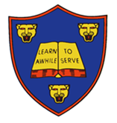

This half term’s DEPTH is:  
**Blue Abyss (Summer 2)**

Hand in: Monday 16th July

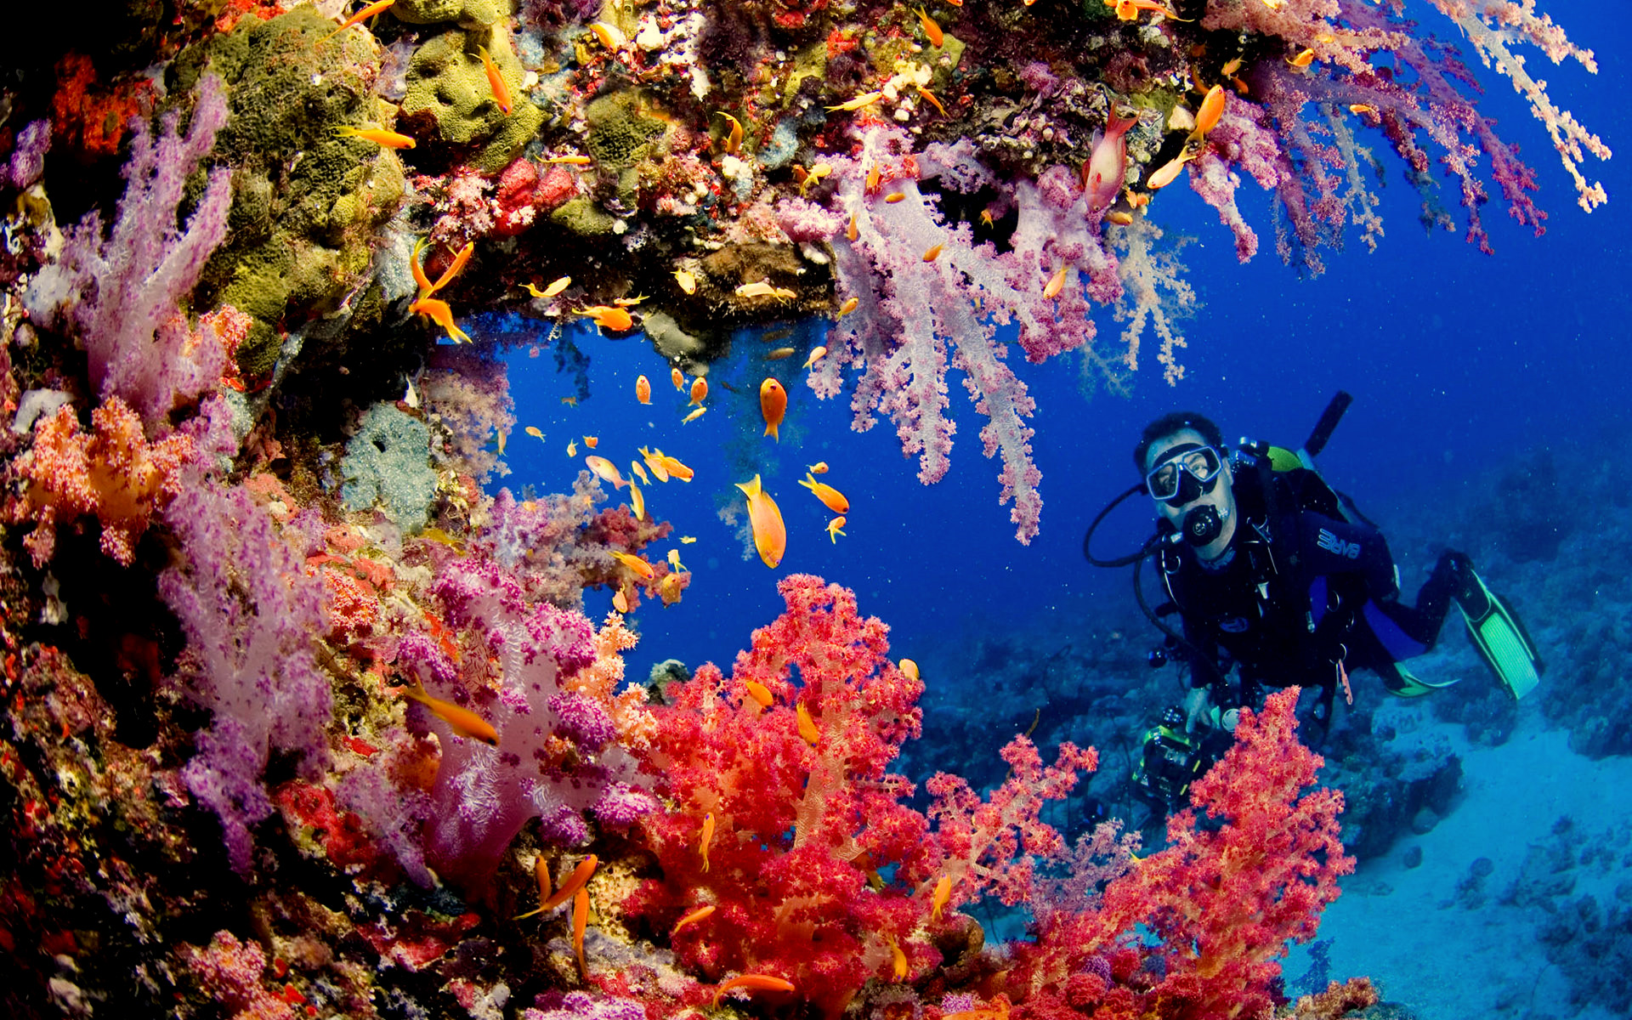

**Children are to pick a maximum of two activities to complete and bring into school.**

**They will be awarded up to 10 stars for both completed pieces of work.**